DRAFT Five-Year Master Plan 2018
Charter Township of Garfield
Grand Traverse County, Michigan

Table of Contents
Introduction 4
Overview 6
Map 1. Location Map 6
Map 2. Grand Traverse County Map 7
Map 3. General Garfield Township Overview Map 8
Existing Land Use 9
Residential & Commercial Growth Trends 11
Map 4. 2014 Land Use Map 12
Map 5. 1990 Land Use Map 13
Surrounding Zoning & Planned Land Use 14
The City of Traverse City 14
East Bay Township 14
Blair Township 14
Long Lake Township 15
Elmwood Township 15
Housing 16
Diversity 16
Accessibility 16
Affordability 17
Figure 2. Low-Income Households and Affordable Rentals by Township 17
Housing Condition 18
Location 18
Transportation & Community Services 19
Roadways & Transportation Planning 19
Alternative Transportation 20
Air Travel 21
Rail Travel 21
Maritime Shipping 21
Utilities 22
Schools 22
Emergency Services 23
Natural Resources 24
Silver Lake 24
Boardman Lake 25
Boardman River 26
Kids Creek Watershed 27
Invasive Species 27
Green Infrastructure 28
Parks & Recreational Opportunities 29
Township-owned Parks 29
Description of Public Input 30
Survey 30
Stakeholder Engagement 30
Vertical & Horizontal Plan Consistency 30
Availability for Review 31
Open Meetings & Public Hearings 31
Future Land Use & Thoroughfare Plan 32
Future Land Use Category Descriptions 32
Corridor Planning 38
Non-Motorized Plan Map 43
Zoning Plan 44
Implementation 48
Appendix 50
Charter Township of Garfield Community Survey Methodology 50
Copy of Survey Instrument 51

Introduction

The Charter Township of Garfield Planning Commission has developed this 5-year Comprehensive Plan (or Master Plan) after undertaking a thorough process of inventory, analysis, and public input collection. This Plan is a road map for land use decisions to be made over the next five years and beyond. The process of preparing the Plan has given the Township a better understanding of its residents’ needs and desires for the future growth of the Township.

The Plan contains the following components:

Overview
This chapter includes a brief description of the Township’s location and population trends.

Existing Land Use
This chapter is a more subjective analysis of recent and current land use and development patterns within the Township. This chapter will also include a brief analysis of the land use trends of surrounding jurisdictions and includes maps, pictures, and text in an effort to present a description of the Township as it exists today. This chapter concludes with residential and commercial construction growth trends over the past five years.

Housing
This chapter presents a specific analysis of housing trends and conditions including the number and types of housing units, the cost and value of the units, and the age of housing in the Township. Trends are used to project anticipated development need and demand in the future.

Transportation & Community Services
This chapter describes existing public services in the Township including the circulation system, corridor planning, public facilities, utilities, schools, and other public services.

Natural Resources
This chapter describes the characteristics and qualities of the environmental amenities and natural features present in the community.

Parks & Recreational Opportunities
This chapter provides a brief overview of the Township’s park system.

Public Input
This chapter describes the process used to collect input from the public and efforts to incorporate that input into this Plan.

Future Land Use Map, Thoroughfare Plan, & selected Corridors,
This chapter provides the vision for future possibilities in the development and use of lands within the Township, including a future transportation plan.

Zoning Plan
This chapter shows how the future land use categories described in this Plan correspond to the zoning districts in the Township’s Zoning Ordinance.

Implementation
This chapter answers the “How” of the Plan. With specific programs, ideas, and regulations such as the Zoning Plan, it will guide the Township along the path of shaping the future.

Appendix
This chapter includes a description of the survey methodology used in distributing the community survey that underlies this Plan, as well as a copy of the survey instrument.

Overview

Map 1. Location Map
This Master Plan was prepared for the Charter Township of Township of Garfield, Grand Traverse County, which is located in Michigan’s northwest Lower Peninsula. This area of Michigan is known as a welcoming four-season tourism destination, drawing visitors to enjoy beaches, vineyards, golfing, natural resources, and culinary pleasures.

Garfield Township is abutted by the City of Traverse City to the north and east. The Township is also bordered by Elmwood Township to the north, Long Lake Township to the west, Blair Township to the south, and East Bay Township to the east. All are located in Grand Traverse County with the exception of Elmwood Township, which is in Leelanau County.

Garfield Township measures 26.59 square miles, with a population density of 611.3 persons per square mile. The Township is one of the most populous municipalities in northern Lower Michigan and the Upper Peninsula. As a tourism destination, the region experiences an annual transient population increase of 11% higher than the permanent population counted by the U.S. Census, with July being the busiest tourism month.

As indicated in Figure 1, the Township’s population has increased steadily over the past 40 years. From 2000 to 2010, the Township’s population increased by 17% to 16,256 residents, making it the most populated municipality in Grand Traverse County. In 2010, the County had a population of 86,986, an increase of 12% from the 2000 population of 77,655—making it the third fastest growing county in Michigan during this time period. Over the same time, the overall population of the State of Michigan actually decreased, the only State in the Union to experience loss. The estimated population of Garfield Township as of July 2015 was 16,673.

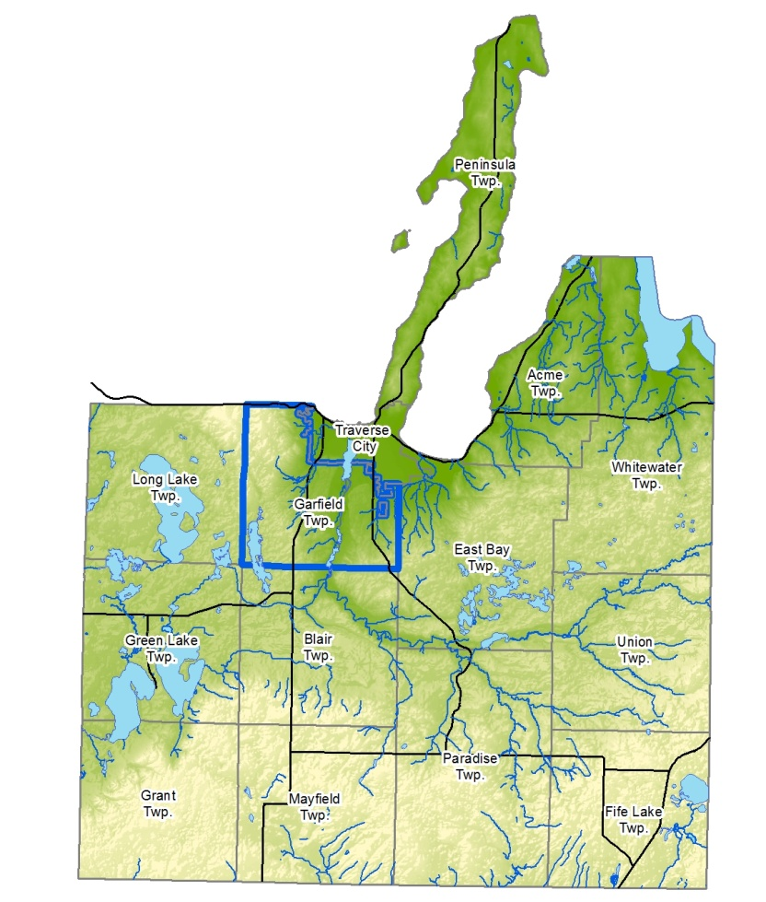
The median age in Garfield Township is 43 years, with 20.1% of the population under age 18 and 20.4% over 65 years. The Township median age is higher than the County-wide average of 41.3 years, which is itself higher than the state and national median averages. The proportion of aged residents is projected to continue to climb to a County-wide average of 36% of households in 2040 being 65 years or older. As the region grows and ages, housing for seniors and the disabled will become increasingly important (see HOUSING element of this Plan).

Map 2. Grand Traverse County Map

Map 3. General Garfield Township Overview Map

Existing Land Use

Once a rural farming community, the Township experienced significant growth from the 1970s through the present as development pressure expanded outward from the City of Traverse City.

The Township now includes a wide variety of land uses, including commercial development, industrial corridors and centers, some remaining agriculture, and residential uses ranging from low to moderately-high density.

Garfield Township is experiencing steady growth, investment, and reinvestment in all aspects of commercial, industrial, and residential development (See "Trends" charts on page 11).

Arterial roadways within the Township include US-31 (a State highway), W. South Airport Road, and Garfield Road, each of which are also among the most developed commercial corridors. Other primary roads include Cass Road, which is heavily industrial, and Silver Lake and North Long Lake Roads, each of which are primarily residential in nature.
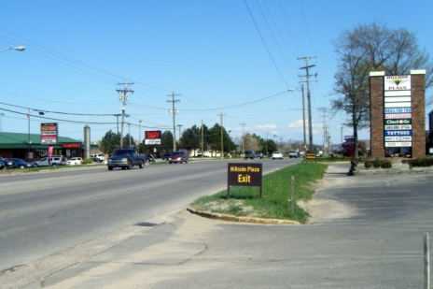
At over 20% over traffic design capacity, South Airport Road is one of the Township’s oldest and most heavily travelled commercial corridors.

Two rail lines cross the Township from north to south on each side of the Boardman River valley and access the Township’s industrial corridors, but are not presently in a condition suitable to accommodate passenger railcars. The Township is also served by the Cherry Capital Regional Airport. Roadways within the Township are discussed in greater detail in the TRANSPORTATION & COMMUNITY SERVICES element of this Plan.
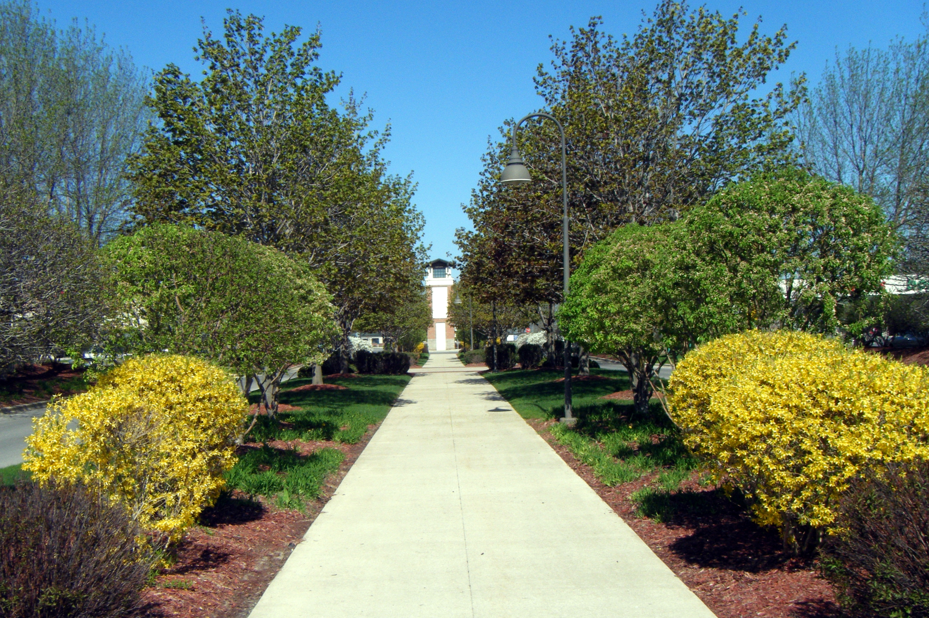
Grand Traverse Crossings Mall is a mixed-use Planned Unit Development (PUD) completed in the late 1990s.

Much of the Township has been developed for commercial uses, such as the Grand Traverse Crossings, Grand Traverse Mall, Cherryland Center, and the Buffalo Ridge Center. The Township boasts one of the highest commercial tax bases in Northern Michigan, including a higher commercial taxable value than its two largest neighbors, Traverse City and East Bay Township, combined. Significant opportunities to redevelop aging commercial corridors exist. Recent commercial development has generally focused on infill redevelopment along US-31. Significant opportunity to redevelop aged commercial properties along South Airport Road also exists.

The Township has likely the highest concentration of industrial activity in northern Michigan, and these land uses are dispersed across the east and south areas of the Township. Recently, the Township adopted Mixed-Use Industrial zoning for these areas to provide flexibility in allowing non-industrial uses which are compatible with traditional industry, but with an emphasis that the primary intent of this district remain industrial in nature.

Over a number of years, the Township was pressured to rezone traditional industrial properties to commercial zoning due to a perceived lack of need, or oversupply of mixed-use industrial sites. However, renewed demand for industrial uses in high-traffic areas, such as near the intersection of W. South Airport Road and Park Drive, has been shown as these historic sites have redeveloped into modern industrial businesses such as building supply, large contractor, and high-tech manufacturing.

As referenced above, Cass Road is a heavy industrial corridor, as is an area bounded by Barlow Street and Park Drive. Other industrial areas include the Hammond Commerce & Industrial Centre, Garfield-Heidbreder Industrial Park, Airport Industrial Park, and Blue Star Estates. The Township is supportive of traditional industry and has granted a number of Industrial Facilities Tax (IFT) abatements to help these businesses grow.

Residential land uses are widely distributed across the Township. Traditional single-family platted developments are generally located on the west side of town, which is also where the Township’s public middle and high school facilities are located. Various projects including residential uses have also been approved as PUDs across the Township. The Township has a number of mobile home parks, including King’s Court, Town and Country, and Meadow Lanes. Large apartment developments include Ridge 45 on LaFranier Road, the Arbors Apartments on Hartman Road, Lake Pointe Village on Park Drive and along the shores of Boardman Lake, and Harbour Ridge and Boardman Lake Apartments on Veterans Drive. As the years have passed, the Township has adapted to recognize and permit a variety of housing types to keep up with the changing requirements of the population.

Although development now occupies a number of former farm fields, large agricultural or otherwise undeveloped parcels still exist, generally within two miles of the south and west Township boundary lines. Many of these properties are being actively farmed, such as the McManus orchards along Garfield Road, Gallagher farm on North Long Lake Road, the Edgecomb farm and market on Hammond Road, and the Robbins farm on Cass Road. Additionally, the Township is home to the Oleson Buffalo herd, once the largest such herd east of the Mississippi River. Regionally, the Traverse City area is widely farmed with an existing and growing number of value-added agriculturally-based businesses.
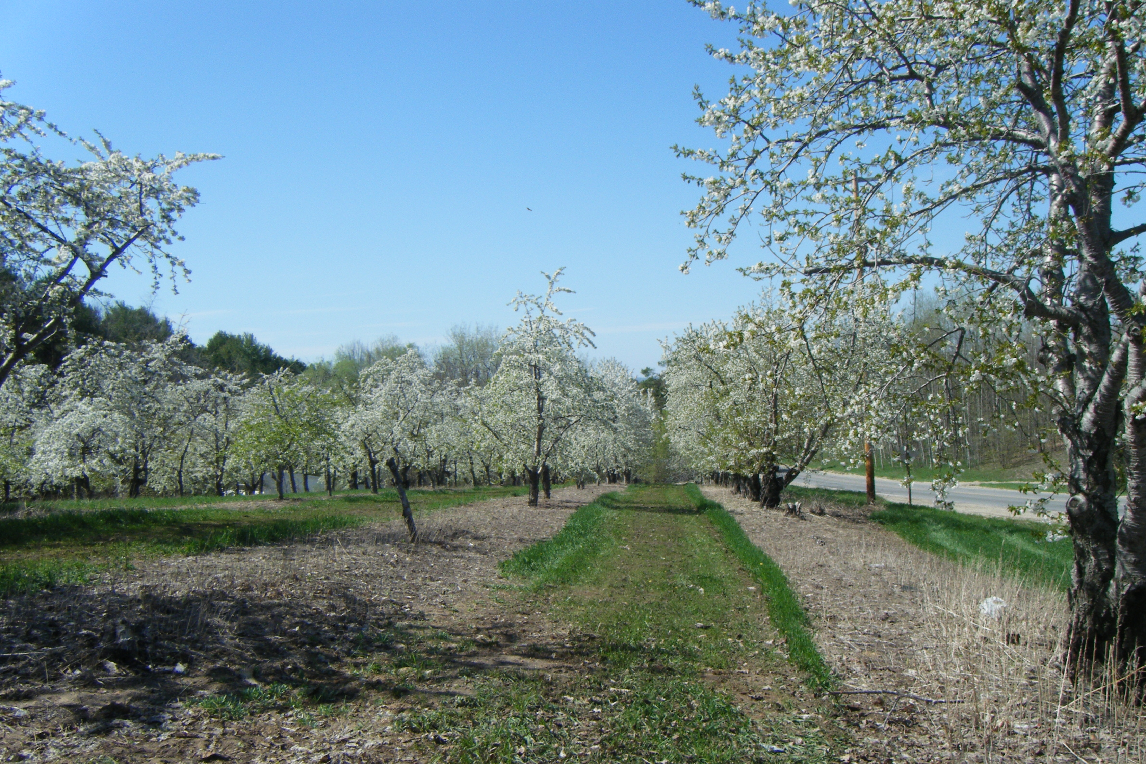
A significant amount of farming still occurs, such as this orchard along Garfield Road.

Following the economic downturn of the mid 2000s, nine approved PUDs stalled or failed completely. In recent years, building activity has returned to some of these projects, primarily within the residential portions of those developments.

Residential & Commercial Growth Trends

Map 4 indicates land use in 2014. Note the concentration of commercial uses along US-31 and South Airport Road, as well as small pockets of commercial activity elsewhere. Primarily industrial areas are located in close proximity to rail lines or major arterial streets. Office “nodes” are found on Cedar Run Road, Silver Lake Road, and South Airport Road. The map reflects the concentrated single-family residential development on the west side of the Township, as well as isolated pockets of low-density housing elsewhere. Higher-density residential development is located on Veterans Drive, Park Drive, and LaFranier Road. Many of the public parks noted on this map have “sprung up” over the past 10 years as the Township concentrated on both the recreational benefits and natural resource protection value of these lands.

Map 4. 2014 Land Use Map

Map 5 shows land use in 1990, which provides a change comparison over the past 24 years of growth. Of note between 1990 and 2014 is infill commercial development along US-31, commercial development along South Airport Road, growth in the traditional single-family areas near Zimmerman Road, and outward expansion toward the Township’s south and west boundaries. Many active farms were lost to development over this period.

Map 5. 1990 Land Use Map

Surrounding Zoning & Planned Land Use

Garfield Township is abutted by the City of Traverse City, Elmwood Township, Long Lake Township, Blair Township, and East Bay Township (see Map 2 and Map 3). Garfield Township has held combined planning meetings with these neighbors and will continue to do so. In addition, the Grand Traverse County Planning Department has done a good job in helping neighboring communities work together towards common goals.
The following is a brief discussion of how neighboring land use and zoning relate to that of the Township:

The City of Traverse City
The City’s zoning is generally consistent with the Township’s with a large amount of land along the boundary line being zoned for residential purposes. Front Street (Long Lake Road) is developed as a medical and office corridor, as it is within the Township. Multi-family residential development along Boardman Lake is consistent. Industrial activity along Park Drive and Woodmere Avenue is consistent. Traverse City has adopted a Corridors Master Plan designed to improve the appearance, function, and vitality of the City’s commercial corridors, many of which are shared with the Township. Joint planning opportunities to broaden the vision of this Corridors Master Plan to include Township corridors should be considered.
One particular portion of the Township, known as the Grand Traverse Commons, is jointly planned and zoned under the authority of the City of Traverse City and Charter Township of Garfield Joint Planning Commission, with a new zoning ordinance adopted in May of 2017.

East Bay Township
Planning and zoning is generally consistent with the exception of East Bay Township encouraging the redevelopment of dated single-family residential lots with multi-family units along South Airport Road. Garfield Township and East Bay Township have collaborated on a corridor plan for Hammond Road.

Blair Township
Blair Township’s development patterns are similar to Garfield Township’s along US-31 in the area near Chums Corners. However, Blair Township’s planning and land use patterns include high-density residential development adjacent to Garfield Township’s plans for low-density residential uses.

Long Lake Township
Planning is consistent between the two communities in identifying low-density residential development along the south three-fourths of the shared border, and moderate-density residential along the northern 1.5 miles of the border.

Elmwood Township
Elmwood Township’s land use and zoning is relatively consistent along the M-72 corridor, which the townships share. Adjacent land uses between the two townships are generally low-density residential.

Housing

This chapter presents an overview of housing trends and conditions in the Township. Trends are used to project anticipated development need and demand in the future. The information used in this section was generated by the 2012 Grand Traverse County Housing Inventory, which is hereby incorporated by reference and should be used where a deeper analysis of housing needs in the region is required.

Diversity
Based on a particular community and household demographic, a variety of housing choices leads to easier decisions regarding the type, location, and size of the housing a family may choose, including whether they rent or own. As an urban area with established municipal water and sewer services, the Township includes a number of apartment complexes and condominium developments, and it therefore has a good mix of single- and multi-family units.
GOAL: Diversity in the rental market is also important in terms of unit size. In particular, there is a known shortage of single-bedroom or loft-style units, leading to a drain on income as renters are forced to choose a larger, more expensive option.
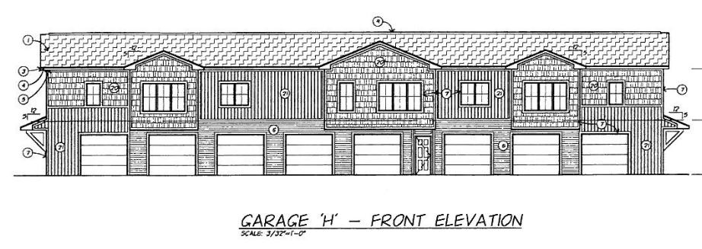
Thoughtful design can provide diverse housing options while also making financial sense for the development community, such as this loft-garage structure at the Arbors Apartments in place of a traditional carport.
Image courtesy of Oppenhuizen Architects.
OBJECTIVE: The Township should encourage development which includes a mix of housing options. The market does seem to be naturally adjusting to meet this demand, as indicated by projects such as the Arbors Apartments constructing 24 loft/garage choices in place of standard carport buildings (see illustration right).

Accessibility
Accessible housing means homes which are designed with features to meet the needs of individuals with either permanent or short-term disabilities. Disability can occur at any age and at any moment, and it is believed that 80% of persons will have a disability at some point in their lifetime. Analysis of apartment complexes in Grand Traverse County indicates that only about 440 out of a total of 7,839 rentals are designated as senior or disabled housing. Between 2000 and 2010, the number of households with individuals over 60 years old increased by 48%.
GOAL: It is increasingly important to consider an adequate accessible housing supply. Accessible housing options will allow aging or disabled individuals to remain in their home.
OBJECTIVE: Consider incentives such as density bonuses to encourage the development community to include accessible housing.

Affordability
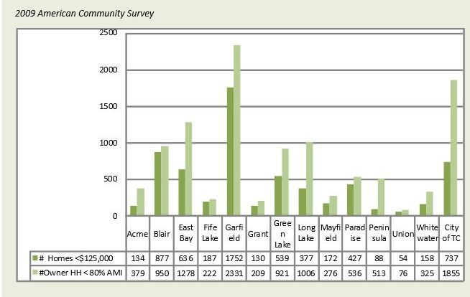
A household is considered low-income based on what percentage of the area median income it is earning. In 2009, the Township had the highest number of “affordable” homes in Grand Traverse County, with 1,752 homes valued at under $125,000. However, with 2,331 low-income, owner-occupied households, the Township is facing an “affordability gap” in the supply of owner-occupied homes (see Figure 2 below).

Figure 2. Low-Income Households and Affordable Rentals by Township
Source: 2012 Grand Traverse County Housing Inventory; 2009 American Community Survey
Rental housing is expected to make up an increasingly important part of the nation’s housing stock. In Grand Traverse County, the majority of rental households (64%) are located in Garfield Township and Traverse City. 39.4% of Garfield Township’s total housing stock was occupied by renters in 2010. Yet, with 1,247 affordable rental units and 1,528 low-income renting families, the demand for affordable rental units is also outstripping supply.
GOAL: Continue to lead the region in supporting affordable housing.
OBJECTIVE: Many of the Township’s residential developments are subsidized to allow lower rents, primarily through the Michigan State Housing Development Authority (MSHDA), but also through the Township Board’s approval of Payment In Lieu Of Taxes (PILOT).

Housing Condition
Evaluating the condition of a community’s housing stock is difficult on a large scale, but several “proxy” factors help to gauge this factor. As described below, a number of factors lead to housing conditions which can negatively affect health and wellness.
The American Community Housing Survey considers the lack of complete plumbing or kitchen facilities as indicators of physical condition issues or substandard quality. In 2009, 185 housing units in Garfield Township lacked complete kitchen or plumbing facilities.
Overcrowding can lead to poor conditions. The level of overcrowding (more than 1 occupant per room) is below both state and national rates for overcrowding.
Overall, the age of the Township’s housing stock is considerably newer than state and national averages, with most structures built within the last 40 years. However, certain Township neighborhoods near the Traverse City limits (which has the oldest housing stock in the County) are older and in poor condition.
Depreciation is an interpretation of the Township Assessing Department which rates conditions from unsound to excellent. Depreciation data indicates that, overall, the housing stock consists of well-maintained homes. However, because the majority of homes in poor condition are mobile homes and the Township has a relatively high number of them, higher concentrations of deteriorating properties are found within the Township.
OBJECTIVE: The Township has adopted a property maintenance code which requires routine inspections for multi-family rental units on an annual basis. Additionally, tenants of any rental unit may report poor conditions and request an inspection. Appropriate actions may be taken by the Building Official to require that deficiencies or safety issues be addressed, up to and including declaring the residence uninhabitable.

Location
Equally important to the need for quality and affordable housing is the availability of desirable housing options close to public transportation, sidewalks and bike paths, jobs, health care, services, shopping, and entertainment, so as to limit the amount a family must spend on transportation costs.
GOAL: Locating new housing developments proximate to these resources can reduce the overall costs of housing and transportation while helping to create more efficient use of infrastructure in existing urban areas.
OBJECTIVE: Target appropriate areas and incentivize their development or redevelopment through density bonuses.

Transportation & Community Services

This chapter describes public services in the Township including the circulation system, public facilities, utilities, schools, emergency services, and other public services.

Roadways & Transportation Planning
As indicated by Map 3, the Township is served by a network of public and private streets. Major north-south roads include US-31, Cass Road, Keystone Road, and Garfield Road, all of which are County Roads except for US-31, which is a federal highway. Major east/west roads include M-72 (a state highway), South Airport Road, North Long Lake Road, West Silver Lake Road, and Hammond Road. With the exception of the state roads, which are administered by the Michigan Department of Transportation, all public roads are administered by the Grand Traverse County Road Commission.
Particular corridors of interest include:
- South Airport Road, which was initially developed for industrial uses but subsequently developed in a primarily commercial manner. This corridor is shared with East Bay Township.
- Garfield Road, which is a shared corridor with the City of Traverse City. The City has adopted a corridor improvement plan for this street which calls for improvements that may also make sense within the Township.
- Hartman Road, Hammond Road, Cass Road, and Keystone Road are each key factors in the long-running discussion of improving east-west connectivity throughout the Grand Traverse region. Hammond Road is a shared corridor with East Bay Township, and Cass and Keystone Roads are shared with Traverse City to the north and Blair Township to the south.
- LaFranier Road and Barlow Road, which serve dense urban areas but lack adequate pedestrian facilities.
Corridor Plans for the above-referenced roadways are discussed in greater detail in the Future Land Use & Thoroughfare Plan element of this Plan.
The Traverse Transportation Coordinating Initiative (TTCI) provides coordinated transportation funding and planning for the Traverse City Urban Area. TTCI (formerly named TC-TALUS) was the lead in the development of the Grand Vision, a citizen-driven vision for a six-county area which includes a strong transportation emphasis.
One benchmark for effective road infrastructure is called “Level of Service,”, or “LOS,” which grades roadways from “A,” where traffic is free-flowing, to “F,” where traffic is congested or stopped for long periods. The following major roads were rated in 2007 by vehicle counts and projected out to 2035 by traffic modeling programs as follows:
- South Airport Road, full corridor. 2007 LOS – E. Projected 2035 LOS – F.
- Garfield Road, north of South Airport Road. 2007 LOS – C. Projected 2035 LOS – D.
- Garfield Road, south of South Airport Road. 2007 LOS – C. Projected 2035 LOS – D.
- Keystone Road, north of Hammond Road. 2007 LOS – A. Projected 2035 LOS – D.
- Keystone Road, south of Hammond Road. 2007 LOS – F. Projected 2035 LOS – F.
- N. Long Lake Road, west of Zimmerman Road. 2007 LOS – C, E. Projected 2035 LOS – F.
- N. Long Lake Road, east of Zimmerman Road. 2007 LOS – B. Projected 2035 LOS – C.
- LaFranier/Barlow Roads, full corridor. 2007 LOS – C. Projected 2035 LOS – B/C.
- W. Silver Lake Road, north of Boone Rd. 2007 LOS – C. Projected 2035 LOS – D.
- W. Silver Lake Road, north of Boone Rd. 2007 LOS – C. Projected 2035 LOS – D.
The above ratings indicate that, generally, the Township’s roadways are overly burdened or will become so within the next couple of decades if the “status quo” holds.
GOAL: Build a basis of support for potential remedies to overburdened roadways.
OBJECTIVE: Work with local road agencies to develop access management plans, to consider signal improvements, or to consider roadway reconfigurations. Support the development of alternative transportation to reduce demand on area roadways. Require detailed traffic impact analysis in development review and consider the impact of additional traffic in the legislative review process.

Alternative Transportation
Opportunities for alternative (i.e. other than a personal vehicle) transportation vary depending on geographic location within the Township. The Bay Area Transportation Authority (BATA) provides public transit options for certain areas of Garfield Township but does not extend service throughout the Township. BATA’s goal is to continue its growth of fixed routes to service densely populated and highly frequented locations.
GOAL: Improve public transportation opportunities within densely populated and highly frequented locations.
OBJECTIVE: Collaborate with BATA when new developments, roadway improvements, and route planning are underway. Consider zoning ordinance requirements for the provision of facilities such as bus stops and shelters.
Similarly, non-motorized routes reach certain developed areas of the Township but do not yet reach the perimeter. The Mall Trail parallels US-31, linking the City of Traverse City with the Grand Traverse Mall area. The Boardman Lake Trail follows the east side of the lake and will eventually encircle it. The Buffalo Ridge Trail is a mostly completed trail that connects the western developed areas of the Township with the Traverse City urban area, linking neighborhoods, parks, and schools along the way. Multiple natural-surface trails within the Township’s parklands also exist, serving both the park users and destination-driven travel. The Township has developed a non-motorized improvement plan to meet the need for both recreation and alternative transportation and requires non-motorized improvements by ordinance.

GOAL: Improve non-motorized opportunities throughout the Township.
OBJECTIVE: Using a combination of public funds, grants, and zoning ordinance requirements, implement the Township’s non-motorized plan.

Air Travel
The Grand Traverse Region is served by the Cherry Capital Regional Airport, a public-use facility adjacent to the northeast corner of the Township. The airport provides both passenger and cargo service, and it is also home to the U.S. Coast Guard Air Station, Traverse City.
The airport’s most recent master plan includes a recommendation to develop a consolidated air freight handling area in the southwest quadrant of the airport, to be accessed from Garfield Avenue. This proposed freight area carries with it unknown effects of increased truck traffic on nearby corridors including Garfield Avenue and South Airport Road.

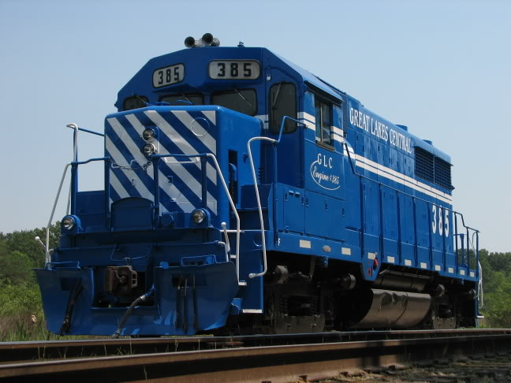
Great Lakes Central Railroad, the largest regional railroad in Michigan, plans to establish regional passenger service betweeen Traverse City and Ann Arbor.

Rail Travel
Two rail corridors bisect the Township on a north-south route—one each on the east and west sides of the Boardman River. The lines are occasionally used for freight but are not currently rated to accommodate passenger traffic. However, future opportunities may exist to repair and upgrade the rail lines to provide an additional mode of travel between Traverse City and southern Michigan, such as Great Lakes Central Railroad’s planned passenger service between Ann Arbor and Traverse City.

Maritime Shipping
Although located on the shores of the Great Lakes, the Traverse City region does not actively import or export products by water. The area’s only deep-water port is located in Elmwood Township, just north of Garfield Township. This port has been used in the past for coal, oil, and fuel deliveries but is currently inactive. The future use of this port is uncertain at this time.

Utilities
Municipal sanitary sewer and water services are concentrated to the north-central portions of the Township and are less available in the northwest quarter and southern areas. Sewer and water facilities are administered by the Grand Traverse County Department of Public Works.
GOAL: Direct development to areas which are served by adequate facilities.
OBJECTIVE: Identify areas with existing utilities which can support higher density and mixed uses.
Well and septic permits, where municipal sanitary sewer and water are unavailable, fall under the jurisdiction of the Grand Traverse County Health Department. Due to State and local law, connection to (and possible extension of) municipal facilities are required where a project boundary falls within a certain distance of a property line.
The Township does not have an extensive storm drain system, though some infrastructure does exist on heavy arterial roads such as US-31 and Garfield Avenue. Generally, stormwater management occurs through on-site infiltration basins. The Township has in recent years encouraged, and in some cases required, the implementation of Best Management Practices to improve filtration of accumulated debris and chemicals that could adversely affect water quality. The Township enforces its own Stormwater Control Ordinance.
GOAL: Ensure storm water controls are considerate of environmentally sensitive areas.
OBJECTIVE: Incentivize or require Best Management Practices such as low-impact design.
Much of the Township is served by natural gas (DTE Energy) but many of the outlying areas rely on propane for a heating source.
Electricity is provided by either Traverse City Light & Power, Cherryland Electric, or Consumers Energy, depending upon location.

Schools
Traverse City Area Public Schools (TCAPS) is the primary K-12 public education provider in the Township. Traverse City West Senior High School, Traverse City West Middle High School, and Silver Lake Elementary School are all located within the Township. Additionally, many homes are within the Traverse City East district, which operates K-12 schools in East Bay Township and the City of Traverse City. The approximate TCAPS enrollment is 10,267 students.
The Grand Traverse region is home to Northwestern Michigan College, a publicly funded community college which offers associate degrees and professional certificates, bachelor's degrees through the Great Lakes Maritime Academy, and eight partner universities grant baccalaureate, graduate, and doctoral degrees. Additionally, the Traverse Bay Area Intermediate School District (TBAISD) operates a Career Tech Center on Parsons Drive in the City of Traverse City as a secondary career and technical education center.
Additional schools include The Greenspire School, a publicly funded Montessori, The Children’s House, a privately funded Montessori, and private schools Traverse Bay Christian, Traverse City Christian, and Traverse City St. Francis.

Emergency Services
The Grand Traverse Metro Emergency Services Authority (Metro Fire) provides services to Garfield Township, East Bay Township, and Acme Township. Metro Fire consists of the three former Township fire departments which were consolidated in 1980. The Authority operates two of its five stations within Garfield Township, including Station 11 along Veteran’s Drive and Station 12 on East Silver Lake Road, adjacent to the Silver Lake Recreation Area Park (see Map 3).
Police protection is provided by the Grand Traverse Sheriff’s Department. The Sheriff Department’s home office is on Woodmere Avenue within Traverse City, but the Department also maintains a satellite office within the Garfield Township Hall on Veterans Drive.
Ambulatory services are provided via Northflight EMS, the largest Emergency Medical Service provider in northern Michigan, which provides integrated ground and air transport for critically ill and injured patients.
With a high proportion of the County’s population, Garfield Township consistently experiences the highest call volumes for emergency assistance.

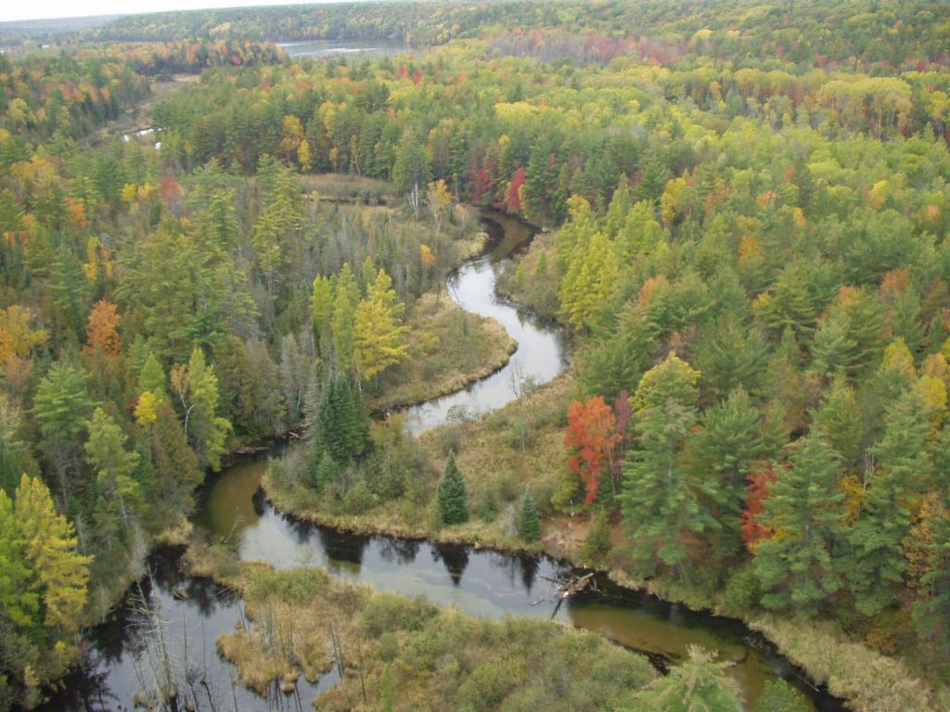
Natural Resources

Silver Lake, Boardman Lake, and the Boardman River are the most prominent natural features within Garfield Township. The river flows north through Garfield Township before emptying into Boardman Lake, which subsequently enters the City of Traverse City before draining to Grand Traverse Bay. The Boardman River and Boardman Lake divide the Township from east to west. Roughly one-quarter of the Township’s geographic area lies to the east of the river and lake.
A number of tributaries in the Boardman River watershed are also located within Garfield Township. These tributaries include Miller Creek, Jack’s Creek, and Kids Creek. Mitchell Creek is located in the east of the Township and drains directly to the East Grand Traverse Bay. The Township is master planned to protect and enhance these surface water resources, as well as associated wetland areas.
Topographic elevations fall from a high point of about 1,100 feet above sea level in the west of the Township, to roughly 600 feet within the Boardman River Valley, before rising once again to over 900 feet above sea level in the southeast corner of the Township.
Boardman River Valley

GOAL: Protect, enhance, and showcase the natural environment.
OBJECTIVES: Implement the Green Infrastructure Plan. Make environmentally conscious decisions in review of development applications or zoning policy considerations. Continue to work with area environmental groups to improve the health of the environment.
Consider establishing a comprehensive natural resources overlay zoning district similar to what has been established in neighboring communities. Protect streams, wetlands, and water bodies from direct or indirect stormwater runoff or other encroachments.

Silver Lake
Silver Lake is located in the southwest corner of the Township and measures 645 acres. The shoreline has been heavily residentially developed, and the lake is used primarily for boating opportunities for lakefront residents and the general public. Silver Lake is divided north to south between Garfield and Blair Townships. The lake’s water level is regulated by a drainage control device under the jurisdiction of the Grand Traverse County Drain Commissioner.
The Township’s Silver Lake Recreation Area is the only public park with frontage on Silver Lake. The Michigan DNR maintains a boat launch on East Silver Lake Road; however, swimming is not permitted at the launch. Anglers can expect to catch a variety of fish including bluegill, bass, northern pike, walleye, and yellow perch.

Boardman Lake
Boardman Lake is a 315-acre natural lake within the Boardman River watershed. The water elevation is approximately 9.1 feet above its historic natural level due to the Union Street dam in Traverse City. The southern half of the lake is located within Garfield Township, whereas the northern half is located within the city limits of Traverse City.
The shores of Boardman Lake have been developed for residential purposes within both municipalities. In the past, the lake was an industrial hotbed and certain areas are still used for this purpose. Unfortunately, past industrial activities resulted in a number of contamination sites, primarily concentrated in the northwest corner of the lake near 14th Street.
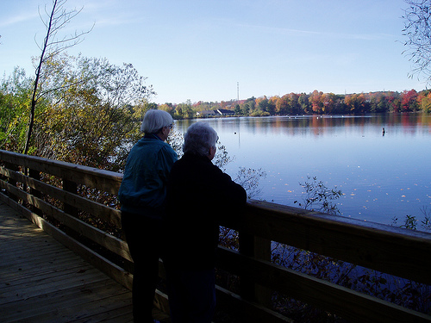
Hikers enjoying the Boardman Lake Trail

Public enjoyment of this resource is lower than usual for a lake in an urban area due to the contamination sites. However, studies such as the Boardman Lake Management Plan have indicated that the contamination is contained in the lake bottom and that the water is fine to swim in and the fish are safe to eat. By continuing to improve the health of Boardman Lake and working to improve perceptions of the lake, the Township can encourage greater public use and enjoyment of this in-town fishery and recreational resource.
The most recent DNR fisheries survey, conducted in 2003, indicated healthy populations of yellow perch, walleye, sunfish, and smallmouth bass that were from 1 to 2 inches above State averages in terms of growth rates. Because of past slow growth rates of northern pike, the DNR removed the minimum size limit of the species in 1983, and the northern pike in the lake are now also above State averages. The DNR has studied the health of the fish and determined no unsafe contamination. In any case, even if fisherpersons choose not to keep their catch due to contamination concerns, the lake is an excellent in-town fishery.
There is a public boat launch at Traverse City’s Hull Park on the northeast end of the lake, as well as opportunities to launch canoes, kayaks, and other lightweight boats from the County’s Medalie Park on the south end of the lake. An organization named Traverse Area Community Sailing offers sailing programs which are popular among all age groups.
The Boardman Lake Trail has been constructed along the entire east shore of the lake, and plans to complete the pathway all the way around the lake are ongoing. Opportunities to include fishing platforms along this trail should be explored.

Boardman River
The Boardman River flows north through Garfield Township before entering Boardman Lake at South Airport Road. An estimated two-million user days are logged on the Boardman River each year for recreational opportunities such as canoeing, kayaking, hunting, and fishing. 36 river miles are presently designated as Blue Ribbon river sections for trout fishing.
Current and past planning efforts have strongly focused on the preservation and recreational value of the Boardman River Valley. The Township’s Boardman Valley Nature Preserve includes over 100 acres, 1.5 miles of trails, and over a mile of river frontage on the west bank. The County’s Natural Education Reserve, which abuts the BVNP to the south, includes an additional 505 acres and 7 miles of trails along both banks of the river.
The Boardman River has been impounded by a series of dams since the late 1800s. From upstream to downstream, the dams include Brown Bridge Dam, Boardman Dam, Sabin Dam, and Union Street Dam. Two of the dams, Boardman and Sabin, are within Garfield Township. The three upstream dams have historically been used for hydroelectric power generation, but have not been in operation since 2006 and are now slated to be removed and an open river condition restored. Completion of the removal of Brown Bridge Dam, in East Bay Township, occurred in 2013. The removal of the Boardman Dam occurred in 2017 and the removal of the Sabin Dam is planned for 2018.
As the dams are removed, numerous environmental, community, regional, and educational benefits will be realized. The project will enhance and restore habitat for native and naturalized fish species and organisms that prefer cold water. Over 3.4 miles of free flowing river, roughly 2 miles of which are in Garfield Township, will be restored, and 160 miles of high-quality river habitat will again be linked, unencumbered by dams. More than 250 acres of wetland and nearly 60 acres of upland will be restored.
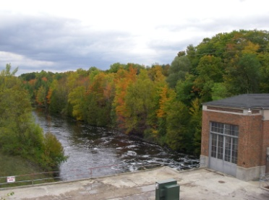
The removal of three dams on the Boardman River, two in Garfield Township, will allow the river to return to a more natural state as a free-flowing, cold-water river. This project is the largest dam removal project in Michigan’s history and the largest wetlands restoration in the Great Lakes Basin.
Source: www.theboardman.org

It is important to recognize that although the dams will be gone, ongoing management and restoration will be necessary for the decades to come, including stream bank restoration, invasive species management, and management of pressures for anticipated commercial use of the river such as livery and guide services.
Concurrent with the dam removal is an effort to create a Boardman River Watershed Prosperity Plan. The goal of the plan is to promote the protection and wise use of the watershed while also reflecting the economic and community development factors of this resource, including business and job creation. A leadership team of twelve Grand Traverse and Kalkaska County regional organizations has been tasked with developing this new approach to natural resource planning.

Kids Creek Watershed
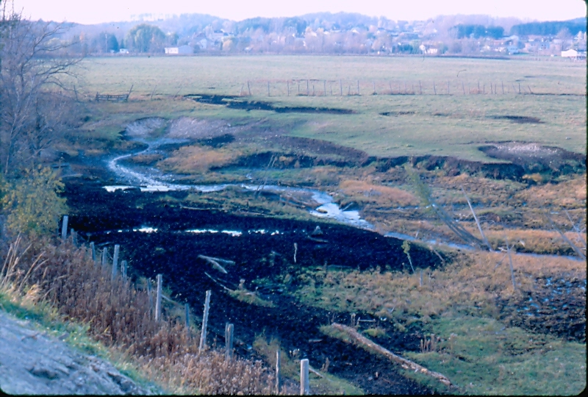
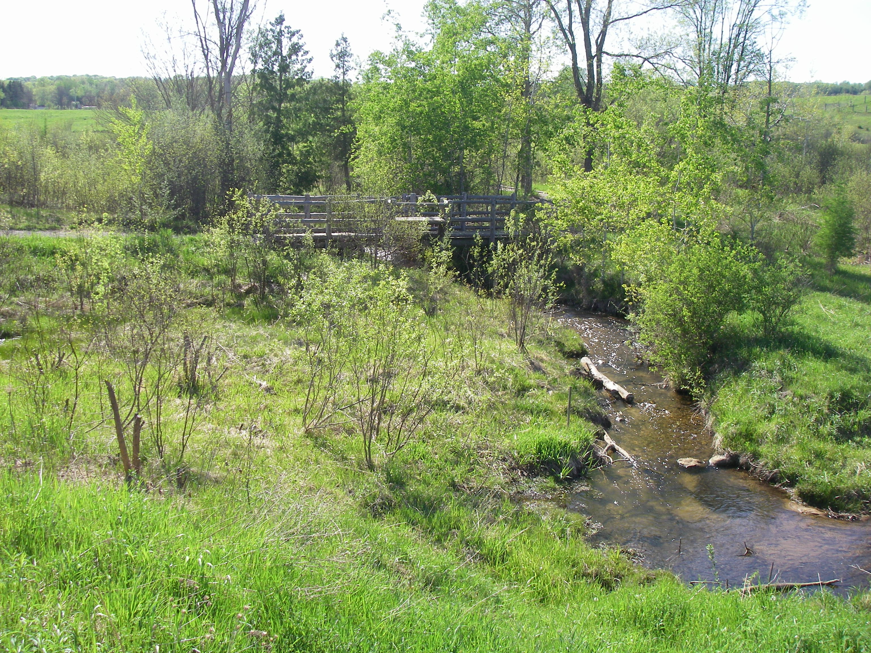
Kids Creek Park; Before and After

Kids Creek is on the State of Michigan’s list of impaired waters due to being overloaded with sediments and high water flows. Where the opportunity arises, the Township works with public and private interests to implement Stormwater Best Management Practices to improve the water quality of this creek and all water resources.
For example, the land that would become Kids Creek Park was dedicated as open space when the surrounding property was developed. Formerly a buffalo pasture, the stream had been impacted by decades of erosion sites. In restoring over 30 specific erosion sites and stabilizing 3,000 feet of stream, an estimated 145 tons of sediment will be stopped annually from entering the stream.
The Kids Creek project shows how urban communities can protect and restore their streams by using techniques like PUDs to help fund such activities. The PUD is a useful tool when contemplating stream corridor protection and restoration projects in a rapidly developing area.

Invasive Species
Invasive species are non-native organisms that cause harm to people, the economy, or the environment. For example, the sap from wild parsnip can cause intense blistering after coming into contact with skin and being exposed to sunlight. These species can harm the economy by increasing costs for farmland management or acting as a host to common pests, and by degrading the natural resources that so many tourists visit this area to enjoy. Perhaps most importantly, invasive species harm the natural environment by displacing the native species which would otherwise support the food web. Invasive species often out-compete and displace native species, reducing biodiversity and destabilizing ecosystems.
Over the past several years, area land managers have grown increasingly concerned about how invasive plant species impact the Grand Traverse region. As a result, the Grand Traverse Regional Invasive Species Network (ISN) was formed to survey and manage species in regional natural areas over a five-county area, as well as to educate the public about our shared natural resources. One of the ISN’s primary goals is to work to prevent the introduction and spread of new invasive species.
Two Township parks, Kids Creek Park and the Grand Traverse Commons Natural Area, have been identified as already significantly impacted by invasive plants.
Water resources, including Silver Lake, have also been impacted by invasive aquatic species, including Eurasian Milfoil, the Round Goby, and the Zebra Mussel.

GOAL: Attempt to limit the spread of invasive species and reduce the impact of invasive species already present in the area.
OBJECTIVES: Require the incorporation of a majority of native plantings in commercial landscaping.

Green Infrastructure
Green infrastructure is a combination of linear or contiguous open space, habitats, wildlife corridors and trails which link parks, nature reserves, and other open areas. The foundation of a green infrastructure system includes elements such as woodlands, wetlands, streams, rivers, and grasslands. The network is anchored by a number of “hubs,” or large areas of protected lands, which are then linked by a series of natural resource corridors.

Hub

Hub

Hub

Hub

Corridor
Corridor
Corridor
Corridor
Green Infrastructure
Network Components

Parks & Recreational Opportunities

Following a significant public process, the Township adopted a detailed 5-Year Parks and Recreation Master Plan, which is hereby incorporated into this Plan. This section is intended to provide a brief overview of parks and recreation activities in the Township.

Township-owned Parks
Garfield Township owns and maintains five parks and natural areas, including the Grand Traverse Commons Natural Area, Kids Creek Park, the Miller Creek Nature Reserve, the Boardman Valley Nature Preserve, and the Silver Lake Recreation Area. Together, these areas provide over 525 acres of active and passive recreation. Prior to 1993, when Grand Traverse Commons was acquired, the Township owned no parkland.
As described in the highlights below, some of the Township’s parks came about through partnerships with the development community, particularly as open space and environmental preservation techniques within certain PUDs.
- Grand Traverse Commons. 142 acres of wooded, hilly natural area adjacent to the Village historic redevelopment district.
- Kids Creek Park. 20 acres of relatively level stream environment, including a branch of Kids Creek. The park was dedicated to the Township as part of the Great Buffalo PUD project and has undergone extensive environmental rehabilitation.
- Miller Creek Nature Reserve. 89 acres of varied topography, including multiple branches of Miller Creek. Much of the parkland was dedicated as open space elements of surrounding PUDs.
- Boardman Valley Nature Preserve. 187 acres of lowlands and uplands along both banks of the Boardman River. The park has been developed in phases through a series of Michigan Natural Resources Trust Fund Grants. Although primarily in a natural state, the northern area of the park includes tennis, pickleball, and beach volleyball.
- Silver Lake Recreation Area. 85 acres of varied topography and the Township’s only park which includes a wide variety of active recreation, including walking trails, tennis, basketball, playgrounds, disc golf, multi-purpose athletic fields, and a dog park.
Guided by the Parks and Recreation Master Plan, the Parks and Recreation Commission is actively planning and budgeting for the continued improvement of the Township’s parklands.
Multiple outside organizations also maintain parkland within the Township, including the State of Michigan, Grand Traverse County, the City of Traverse City, the Grand Traverse Regional Land Conservancy, and the Traverse City/Garfield Township joint Recreational Authority. Although not owned by the Township, these resources provide an important source of recreation. All together, nearly 1,500 acres of public land is available for enjoyment, with many of these parks also serving a key function in the existing and planned non-motorized network.

Description of Public Input

This chapter describes the public processes used by the Township to ensure that this Plan closely reflects the policy priorities of Township residents.

Survey
The Township created a 20-question comprehensive community survey to serve as a key indicator of residents’ opinions regarding the future growth and development of their community. Prior to distribution, a draft of the survey was twice presented to the Township Planning Commission for review and their suggestions were incorporated. Next, the survey was distributed in two separate but complimentary ways. First, it was posted online on the Township’s website for anyone browsing to complete. In addition, it was mailed to a random sample of 3,600 qualified voters in the Township.
The electronic survey had approximately 130 respondents. The mailed survey had just over 800 respondents. The results from both the electronic and mailed surveys were extensively analyzed by Planning Department Staff and directly informed the drafting of the goals and objectives in this Plan. (See APPENDIX for a copy of the survey instrument and a more detailed description of the methodology used in distributing it and in interpreting the results).

Stakeholder Engagement
Several meetings were held with key stakeholder groups and opportunities for partnership and collaboration were identified. These opportunities are embodied in the Plan. Groups include:
- Cherry Capital Airport
- Traverse City Area Public Schools (TCAPS)
- Bay Area Transportation Authority (BATA)
- Grand Traverse County Road Commission (CTCRC)
- Traverse Transportation Coordinating Initiative (TTCI)

Vertical & Horizontal Plan Consistency
The Grand Vision is a citizen-led vision for the future of land use, transportation, economic development, and environmental stewardship across six counties in northwest Lower Michigan. Consistency with the Grand Vision’s guiding principles was a high priority in creating this Plan. In the development of each goal and objective contained in this Plan, the extent to which each advances the Vision’s guiding principles was carefully considered.
The Grand Traverse County Master Plan is based on communication and collaboration among all of the planning commissions in the County, including the Charter Township of Garfield’s. It is intended to bridge the gap between the broad Grand Vision discussed above and local master plans. Rather than containing goals and objectives, the County Master Plan’s values and strategies reflect the common principles of all of the planning commissions. For these reasons, consistency with the County’s Master Plan was a high priority in creating this Plan as well.
Finally, the land use and zoning of adjacent jurisdictions was reviewed for consistency with the Charter Township of Garfield’s. Neighboring master plans reviewed include: The City of Traverse City, East Bay Township, Blair Township, Long Lake Township, and Elmwood Township. Efforts to collaborate with these jurisdictions will continue, especially in the area of corridor planning. (See pages 14 and 15 of this Plan for a more detailed discussion of the extent to which each neighboring jurisdiction’s zoning and land use is consistent with Garfield Township’s).

Availability for Review
Since January of 2017, a draft version of this Plan has been available for review on the Township’s website. The link was prominently displayed on the Planning Department section of the website at the top of the homepage. The Township’s website does include a resident comment feature and Staff regularly reviews comments received. Such a feature leaves open a channel for feedback on this Plan in particular. In addition, a print copy has been available at the Charter Township of Garfield Hall since January of 2017 as well.

Open Meetings & Public Hearings
Early on in the process of drafting this Plan, two open joint planning commission meetings were held with neighboring East Bay and Blair Townships. The purpose of these meetings was to discuss similarities and differences between the communities regarding visions for future land use. The input gained at these meetings provided important context as the drafting of this Plan continued. Also early in the drafting process, an open joint meeting was held with the Charter Township of Garfield Planning Commission and Board of Trustees to discuss the drafting of this Plan. This meeting allowed for Staff to take into account the views of both bodies involved in approving development proposals in the Township.

This Plan was formally reviewed and opportunity was given for public comment at two separate public hearings which were advertised in the local news: one at the Township Planning Commission level and another at the Township Board of Trustees level. Holding a public hearing at both levels as opposed to just the Planning Commission level allowed for a more diverse sample of the Township to attend, since these meetings are held at different times and on different days. Each of the meetings discussed in this section were televised and made available on the Township’s website, as well as the UpNorth Media Center’s website.

Future Land Use & Thoroughfare Plan

This chapter will provide the vision for the future possibilities in the development and use of lands within the Township, including a future transportation plan.

Future Land Use Category Descriptions
(Note: also refer to Future Land Use Map, Page 36)

Agricultural/Rural Land (No more than 1 unit per acre)
The intent of this land use type is to provide areas for agricultural operations and low intensity land uses in the outlying areas of the Township. These districts are composed primarily of unsubdivided lands that are vacant or are in agricultural use with some dwellings and accessory uses. This area is suitable for large tracts of open space, agricultural areas, woodlands, and fields. It is intended to promote the protection of the existing natural environment and to preserve, enhance, and stabilize the essential characteristics and economic value of these areas as agricultural lands. These districts may be used to encourage development in and near the core areas of the Township by limiting the development densities of parcels less suited for intensive development. This land use type is also used to protect natural resources and environmentally sensitive areas, such as stream buffer zones.
Most compatible zoning districts: R-R/A Potentially compatible zoning district: R-1

Low-Density Residential (From 1 to 3 units per acre)
This designation provides area for traditional single-family residential dwelling units. This includes areas of existing single-family development as well as areas within which such development appears likely and desirable. They are intended to encourage more intensive development in and near the core areas of the Township, with less intensive development moving outward towards the more rural and remote areas of the Township. The designation is intended to encourage a suitable neighborhood environment for family life by including among the permitted uses such facilities as schools and parks that will promote a sense of community and urban vitality.
Most compatible zoning district: R-1 Potentially compatible zoning districts: R-R/A

Moderate-Density Residential (From 3 to 6 units per acre)
This designation provides areas for medium-density single- and two-family residential dwelling units in and near to the developed core areas of the Township. The districts include areas of existing single- and two-family developments as well as areas within which such development appears likely and desirable. This area should encourage a suitable neighborhood environment for family life by including among the permitted uses such facilities as schools, places of worship, and parks. This area is meant to provide a range of housing choices, promote a sense of community, urban vitality, and to facilitate the efficient provision of infrastructure.
Most compatible zoning district: R-2 Potentially compatible zoning districts: R-1/R-3

High-Density Residential (From 6 to 10 units per acre)
This designation provides areas for medium- to high-density single- and two-family residential dwelling units mixed with a variety of multi-family residential dwelling types, including apartments where adequate public facilities and services exist with capacity to serve such development. The districts are composed mainly of areas containing an existing mix of these dwelling types, as well as areas within which such development appears likely and desirable. They are intended to encourage more intensive development in and near the core areas of the Township. Design should encourage a neighborhood environment for family life and include uses such as schools, places of worship, and parks that will promote a sense of community, urban vitality, and the efficient provision of infrastructure. Zoning district regulations should allow for market and design flexibility, while preserving the neighborhood character and permitting applicants to cluster development in order to preserve environmentally sensitive and natural land areas.
Most compatible zoning district: R-3 Potentially compatible zoning districts: R-1/R-2

Mobile Home Residential (State of Michigan defines density)
This designation indicates areas which are suitable for mobile home subdivisions and mobile home parks, including areas of existing developments as well as areas proposed and approved for such development. This classification is intended to encourage medium- to high-density mobile home subdivisions and mobile home park developments where adequate public facilities and services exist with capacity to serve such development.
Most compatible zoning district: R-M

Professional Office
This designation provides areas for service-oriented enterprises and institutions having relatively low traffic generation. This includes areas of existing office developments as well as areas within which such development appears likely and desirable. They are intended to facilitate the support and expansion of local business, while serving as a buffer between residential areas and more intensive commercial areas. Corresponding zoning regulations should be primarily restricted to office and ancillary uses that do not have peak weeknight or weekend usage so as to provide orderly transition and buffers between uses.
Most compatible zoning district: C-O Potentially compatible zoning district: C-L

Commercial
The commercial land use designation indicates where commercial uses of varying intensity may be appropriate. This Plan includes only one broad "Commercial" category intended to encompass a variety of commercial zoning districts which may be appropriate on a case-by-case, property-by-property basis. For example, depending on surrounding land uses and zoning patterns, it may be appropriate to consider zoning a property C-L (Local Commercial) but totally inappropriate to consider zoning property any other commercial zoning district. Zoning district regulations should be designed to protect abutting and surrounding areas by requiring certain minimum yard and area standards which are compatible with those called for in surrounding, non-commercial zoning districts.
Please see the zoning plan for additional information.
Potentially compatible zoning districts: C-L/C-P/C-H/C-G/C-O

Industrial
The intent of the industrial areas is to remain primarily industrial in nature while allowing a limited number of non-industrial uses that are envisioned as accessory or complimentary to existing and future industrial uses of the districts. Non-industrial uses of property within these districts are subject to industrial impacts from adjacent parcels including, but not limited to, noise, dust, and vibrations.
Please see the zoning plan for additional information.
Most compatible zoning districts: I-G/I-L Potentially compatible zoning district: C-L

Grand Traverse Commons
This area indicates the Grand Traverse Commons Redevelopment District, a jointly planned area established under the authority of the Michigan Joint Municipal Planning Act 226 of 2003, as amended. This area is subject to a separate master plan and zoning ordinance.
Most compatible zoning district: GTC

Recreational
This land use designation indicates areas suitable for active and passive recreation, and which are already owned by a municipality or other governmental entity. This classification is not intended to identify future properties which may be acquired as the parkland system grows, but rather to protect and preserve existing parks and sensitive natural areas. This area also includes lowlands along the Boardman River Valley which are currently, or were formerly, inundated by the Boardman River.
Most compatible zoning district: P-R

This page was intentionally left blank.
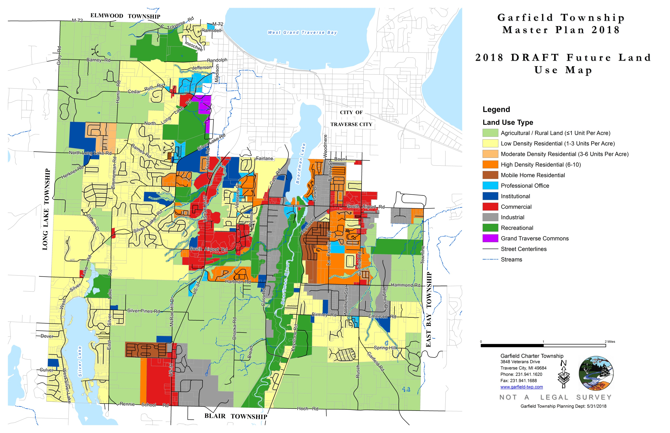

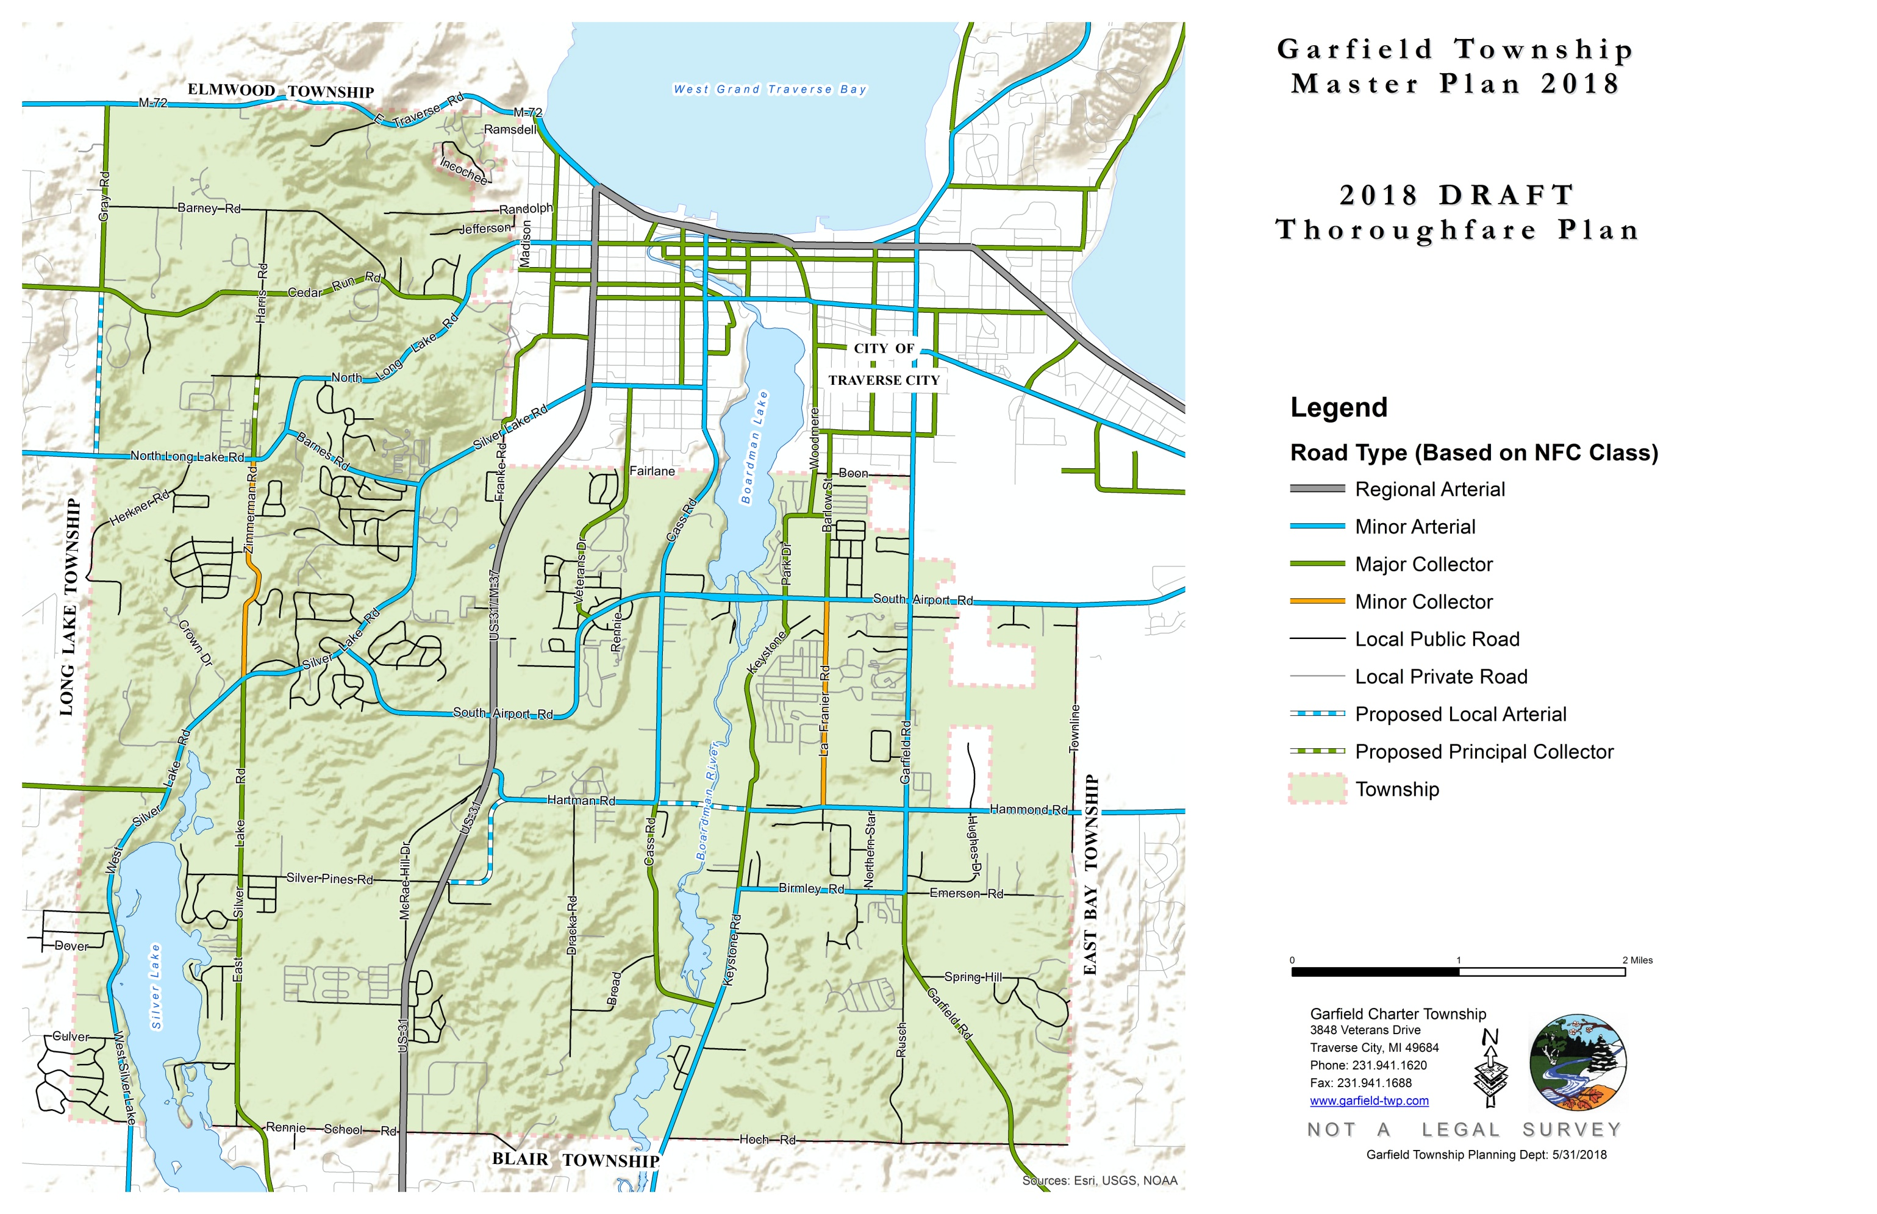
File export: 200DPI TIFF K:\PLAN\Master Plan\Maps and Graphic Exports

Corridor Planning
As briefly discussed in the TRANSPORTATION & COMMUNITY SERVICES element of this Plan, a number of roadway corridors should be studied in greater detail for opportunities to improve both motorized and non-motorized efficiency, as well as the built form of the roadway environment. These particular corridors of interest include West South Airport Road, Garfield Avenue, Barlow Road, and LaFranier Road.
It is not the intent of this Plan to thoroughly analyze these corridors, but a brief summary of the opportunities and constraints of these corridors is as follows:

West South Airport Road between Park Drive and Garfield Road:
This corridor is developed with commercial uses to the east of Barlow Road and with industrial uses to the west of that street. The roadway includes four travel lanes, a center turn lane, and a number of deceleration and turn lanes. Non-motorized pathways are almost non-existent.
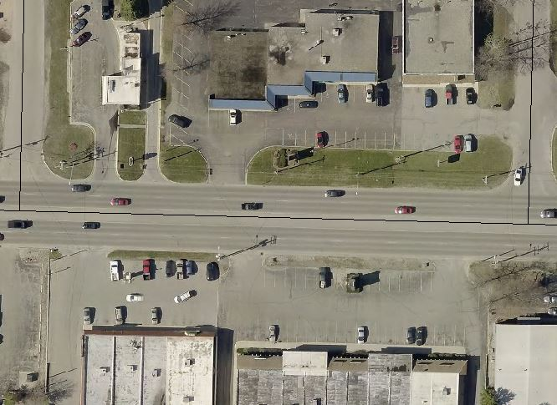
In certain cases, as shown in the graphic to the left, a proper landscaping buffer between parking lots and streets has been provided (see property to the north), but in many cases asphalt extends to within the road right-of-way, greatly reducing green space. Because of the high number of commercial driveways within this corridor, access management is a major concern. Electrical lines within this corridor are all above ground, which further degrades the aesthetics of this aged corridor.
Properly planned and funded, perhaps with the assistance of a Corridor Improvement Authority, this corridor could be re-imagined to greatly improve its function and aesthetic appearance.
West South Airport Road between Cass Road and Park Drive:

This corridor crosses the Boardman River Valley. Uses include industrial to the west, and offices, public parkland, and retail to the east. South Airport Road splits into a boulevard-type street in the area near Logan's Landing. Access management is more properly applied for this section of the roadway than it is to the east.
Non-motorized pathways remain a high priority for this corridor, with a need for improved east-west paths but also for a safe pedestrian connection between the Boardman Lake Trail, to the north, and the Boardman River Trail, to the south. In a 2010 feasibility study, the County Road Commission determined that a pedestrian tunnel under the road near Art Van would be the most preferred option to accomplish this connection, but will come at a high cost and would be best considered in the event that the roadway is completely reconstructed. In 2018, the Road Commission is reconfiguring the boulevard area into a "Michigan left," so that the roadway connection between Racquet Club Drive and Logan's Landing can be converted to a pedestrian-only, signalized crossing.
The grassy and vegetated median within this corridor is irrigated and maintained by the Township. Combined with the parkland on each side of the road in this location, portions of this roadway showcase the natural environment of the Boardman River Valley. By working to "green" the western, industrial section, the Township could unify this corridor into a more welcoming destination to explore and enjoy the Boardman River.
Garfield Road between Boon Street and Hammond Road:
Garfield Road is a highly developed, north-south corridor. It includes a mix of uses including high-density housing, offices, retail, industry, and the Cherry Capital Airport. It is a regional arterial road providing connections to Traverse City from downstate locations.
For the life of this Plan, it is expected that this road will remain as a five-lane road, with two travel lanes in each direction and a middle turn lane. Access management strategies would likely improve the level of service of the corridor.
Challenges of this corridor include a lack of pedestrian connectivity and safe routes, even though pedestrian activity is common along this route. Most often, pedestrians are forced to walk alongside the busy roadway, or within the road itself. Additionally, the built environment is not conducive to the construction of separated walkways.
Streams and wetlands are present in this area. In certain cases, it may be appropriate for the Township to consider shifting allowable density to the areas closest to Garfield Road to protect these resources while providing for continued infill and redevelopment. This discussion could also include an increase in allowable building height where appropriate (keeping in mind the proximity of the airport).
The potential for redevelopment and reuse of this corridor is significant. As properties redevelop, and as the remaining vacant parcels are built on, the Township should take the opportunity to improve mobility along the corridor for motorists, pedestrians, and cyclists.
The variety of uses within this corridor is a strength. With a better non-motorized network, opportunities will increase for this corridor's residents to walk or ride a bike to nearby opportunities for shopping, entertainment, and employment. The Township should encourage a high-density mix of uses within this corridor.
Particular opportunities for redevelopment and density increases within this corridor include the Cherryland Center, at the northwest corner of Garfield and South Airport Roads. In the same vicinity but across Garfield Road and adjacent to the airport, opportunities exist for a land developer to acquire and consolidate older structures. Within this vicinity, there is likely market support for airport-service oriented businesses such as car rentals, conference centers, hotels, and other similar uses.
Barlow Road between Boon Street and West South Airport Road:

Barlow Road is a mixed-use corridor in close proximity to the City of Traverse City. On the west, the current mixed-use industrial zoning remains appropriate.
The east side of the corridor includes commercial and office uses from Floresta Street to West South Airport Road. To the north of Floresta Street, this Plan calls for increased density, potentially including a redevelopment of outdated residential areas. Because of the proximity to walkable employment in both Traverse City and Garfield Township, encouraging affordable housing in this area is a priority.
This street is another example of a corridor with high pedestrian demand but minimal pedestrian facilities. Because of the built environment, separated sidewalks may be difficult to construct, but they should be required wherever feasible. In the absence of sidewalks, designated bike lanes could accommodate both pedestrians and cyclists.

LaFranier Road between West South Airport Road and Hammond Road:

To the south of West South Airport Road, Barlow Road becomes LaFranier Road. This corridor is targeted for higher density residential development because of its proximity to the City of Traverse City and access to public transit.
As with Barlow Road, pedestrian activity along this corridor is consistent. Non-motorized facilities should be required as properties develop or redevelop.

Hartman and Hammond Roads:

Connecting Hartman Road and Hammond Road via a bridge over the Boardman River is a long-running debate for the Traverse City region. At the heart of the discussion is a common belief that this connection would help to relieve east-west traffic congestion across the Traverse City area; in particular, by providing an alternate route to overburdened roads such as South Airport, 8th Street, and US-31.
In the early 2000s, the County Road Commission attempted to fund and build this connection, but due in part to an environmentally insensitive design, the project was shelved in the face of public opposition.
In 2016, as a part of the broader effort to remove three dams on the Boardman River, the Cass Road bridge over the river was replaced. However, transportation models show that the replacement of this bridge will do little to mitigate east-west traffic issues.
Much has changed since the days of the original Hartman-Hammond discussion, when the decision had not yet been made to remove the dams, or to remove and replace a river crossing between West South Airport Road and Beitner Road. The County's population increased from 77,764 in 2000 to an estimated 89,987 residents in 2013 and is expected to continue to grow. This Plan calls for dense residential infill development along LaFranier Road north of Hammond Road and east of the river, and such development would benefit greatly from a direct roadway connection to the commercial centers to the west of the Boardman River.

Non-Motorized Plan

This chapter provides the Township’s non-motorized plan map. This plan guides the Township’s sidewalk and bike path installation priorities, and it is incorporated into the Township’s Zoning Ordinance in Section 522.A.

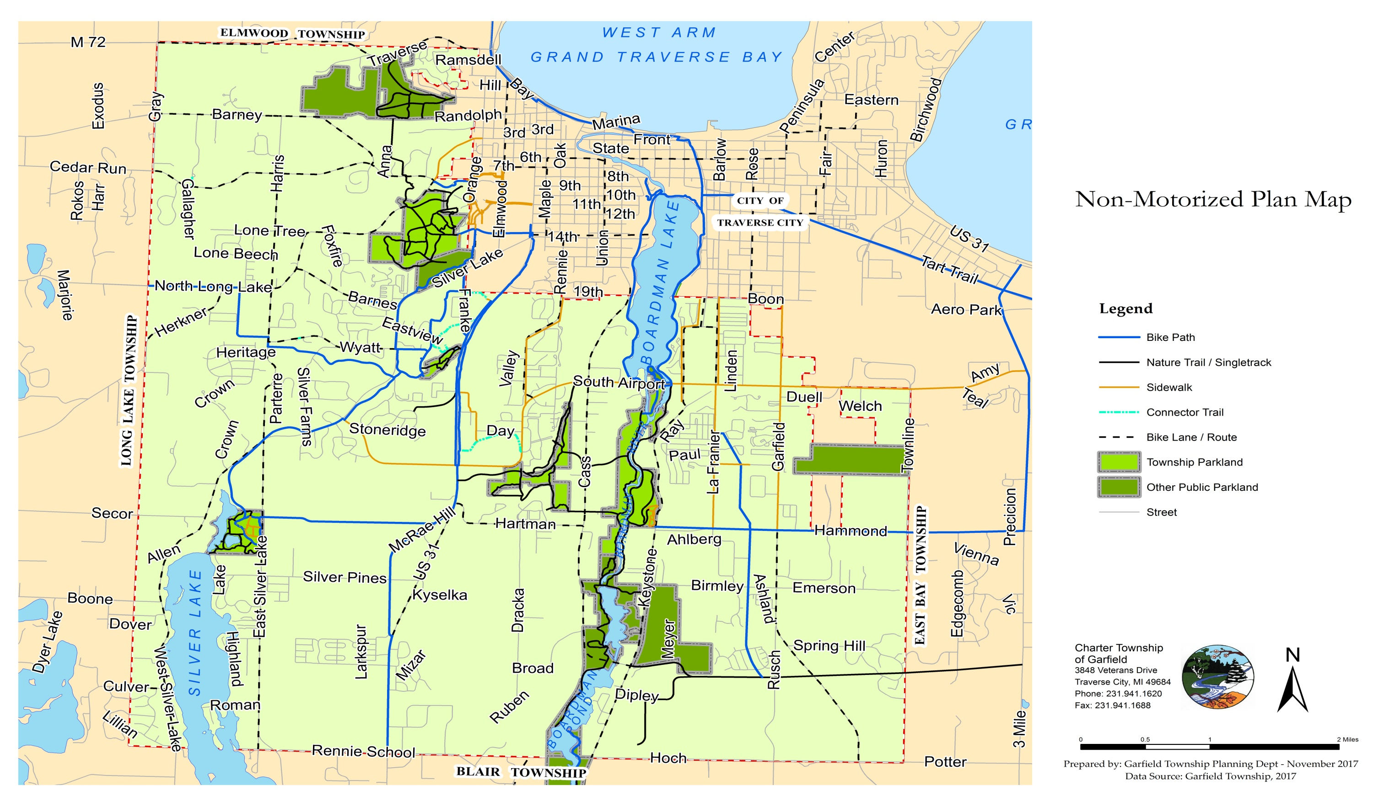

Master Plan Designation | Current Zoning | Zoning Ordinance District Intent | Potentially Compatible District | Considerations for Downzoning (Less Density) | Considerations for Upzoning (More Density)
Low-Density Residential (1-3 U/A) | R-1 Single-Family Residential | The R-1 (Single-Family Residential) districts provide areas for low- to medium-density single- family residential dwelling units. The districts include areas of existing single-family developments as well as areas within which such development appears likely and desirable. They are intended to encourage more intense development in and near the core areas of the Township with less intense development moving outward towards the more rural and remote areas of the Township. The R-1 districts are designed to encourage a suitable neighborhood environment for family life by including among the permitted uses such facilities as schools and parks that will promote a sense of community and urban vitality. | R-R/A/R-1 | R-1 properties are intended to encourage traditional neighborhoods for families that prefer to be located outside mixed use and mixed residential areas. These areas are typically designed and located within walking distance to schools and park areas. Larger minimum lot sizes for this purpose would likely be supported and consistent with the Agricultural and Rural Land Zoning classifications. | A rezoning from R-1 should be discouraged as single family homes and neighborhoods are needed in the Township. A PURD would help increase density and encourage better design.
Moderate-Density Residential (3-6 U/A) | R-2 Two-Family Residential | The R-2 (Single- and Two-Family Residential) districts provide areas for medium-density single- and two-family residential dwelling units in and near to the developed core areas of the Township. The districts include areas of existing single- and two-family developments as well as areas within which such development appears likely and desirable. The R-2 districts are designed to encourage a suitable neighborhood environment for family life by including among the permitted uses such facilities as schools, places of worship, and parks. They provide a range of housing choices and promote a sense of community, urban vitality, and the efficient provision of infrastructure. | R-1/R-3 | A lack of undeveloped R-1 single-family lots outside of mixed use developments is a concern. Standalone single-family projects are in high demand and considered appropriate in areas with water and sewer. This transition may be compatible with the Moderate Density Residential district classification. | A change to a more intense R-3 District may be appropriate in areas identified for redevelopment, high-density, or in areas located near amenities. Special attention should be given to the surrounding land uses when considering a change to a more intense R-3 district or High-Density Residential classification.
High-Density Residential (6-10 U/A) | R-3 Multi-Family Residential | The R-3 (Multi-Family Residential) districts provide areas for medium- to high-density single- and two-family residential dwelling units mixed with a variety of multi-family residential dwelling types, including apartments where adequate public facilities and services exist with capacity to serve such development. The districts are composed mainly of areas containing an existing mix of these dwelling types as well as areas within which such development appears likely and desirable. They are intended to encourage more intensive development in and near the core areas of the Township. The R-3 districts are designed to encourage a suitable neighborhood environment for family life by including among the permitted uses such facilities as schools, places of worship and parks that will promote a sense of community, urban vitality and the efficient provision of infrastructure. R-3 district regulations are designed to allow for market and design flexibility while preserving the neighborhood character and permitting applicants to cluster development in order to preserve environmentally sensitive and natural land areas. | R-2/R-1 | Allowing a downzoning in designated redevelopment areas may be detrimental to the overall redevelopment plan. In some cases, however, when platted subdivisions are in play, a downzoning may accelerate the redevelopment process. Areas designated as R-3 are typically located close to the City core and amenities. The R-3 district is consistent with the High Density Residential Zoning classification; however, where platted subdivisions are prevalent, an R-1 or R-2 designation may be more appropriate and compatible. | The R-3 district allows the greatest density possible.

Zoning Plan

This chapter provides the Township’s zoning plan as required under the Michigan Planning Enabling Act. This zoning plan includes an explanation of how the categories on the future land use map contained in this Plan relate to the districts on the Charter Township of Garfield’s zoning map.

Master Plan Designation | Current Zoning | Zoning Ordinance District Intent | Potentially Compatible District | Considerations for Downzoning (Less Density) | Considerations for Upzoning (More Density)
Mobile Home Moderate/High Density | R-M Mobile Home Residential | The R-M (Mobile Home Residential) districts provide areas for mobile home subdivisions and mobile home parks. The districts include areas of existing developments as well as areas proposed and approved for such development. They are intended to encourage medium to high density mobile home subdivisions and mobile home park developments where adequate public facilities and services exist with capacity to serve such development. The R-M districts are designed to encourage a suitable neighborhood environment for family life by including among the permitted uses facilities that will support and promote a sense of community. | R-M | Caution should be taken when changing a zoning district from the R-M designation. The availability of this type of affordable housing should be considered prior to a change. If the change is going to require additional manufactured home park designations, the district should remain as zoned. The R-M district is consistent with the Medium/High Density Zoning classifications. | The density associated with the R-M districts is determined by the State of Michigan and is typically the maximum permitted on the site.
Agricultural (1 U/A) | A-Agricultural | The A (Agricultural) districts provide areas for agricultural operations and low intensity land uses. These districts are composed primarily of unsubdivided lands that are vacant or are in agricultural use with some dwellings and accessory uses. The A districts are suitable for large tracts of open space, agricultural areas, woodlands, and fields. They are designed to promote the protection of the existing natural environment and to preserve, enhance, and stabilize the essential characteristics and economical value of these areas as agricultural lands. The A districts may be used to encourage development in and near the core areas of the Township by limiting the development densities of parcels less suited for intensive development. The A districts may also be used to protect natural resources and environmentally sensitive areas by preserving these areas for low intensity land uses. | R-R/R-1 | Farmland and value added agriculture should be encouraged in Garfield Township. Historically, the Township has zoned sensitive lands to agricultural to help protect those areas from higher density development. The Rural Land Classification and A Agricultural districts are considered to be compatible. | In many instances the land is not considered high value farmland and a change to a residential district may be appropriate. An evaluation of the properties location, proximity to amenities, and surrounding land uses should determine the most compatible district and density. A change to R-R would likely be supported due to the similarity with the districts. A PURD should be encouraged or required over a request to rezone farmland to a more intense residential use.
Commercial | C-L Local Commercial | The C-L (Local Commercial) districts provide nodal areas for convenient, day-to-day retail shopping and service facilities, servicing persons in the adjacent residential areas and designed in scale with surrounding residential uses. The districts include areas of existing commercial use as well as areas proposed and approved for such development. Due to their local service nature, C-L districts are likely to be standalone or small collective sites located so as to have a minimum impact upon the surrounding residential areas. C-L district regulations are designed to protect abutting and surrounding residential areas by requiring certain minimum yard and area standards which are compatible with those called for in the residential districts. These districts are also intended to reduce automobile trips by permitting a limited group of commercial uses to be located in close proximity to residential areas. | C-O | The C-L zoning classification is viewed more of a transitional commercial district, however, some uses permitted in the district may be deemed too intense or incompatible with adjacent residential uses. The C-O district should be considered as a possible alternative to a C-L designation. | The commercial designation does not contemplate the various types or intensities of the commercial districts. This increases the need for the Planning Commission to evaluate the adjacent land uses, their compatibility, the need for increased commercial, and combined intensity of the change when rezoning to a more intense commercial designation.
Commercial | C-G General Commercial | The C-G (General Commercial) districts provide areas for a broad range of commercial activities and services designed to cater to the needs of a large consumer base. The districts include areas of existing commercial developments as well as areas within which such development appears likely and desirable. They are intended to encourage more intensive commercial development in and near the core areas of the Township. The C-G districts are designed to support diversification of the economic base in a manner compatible in use, character, and size to the site and the surrounding areas. | C-H/C-P | The more restrictive C-H District is similar to the C-G district as it relates to allowable uses; however, it is more advanced from a planning perspective due to cross-access requirements, and service drive agreements and installations. A change to the C-H district would likely be encouraged. Discussion should continue regarding the combination of these two districts. | Due to the leniency of the C-G district, a change to a more lenient or higher density district would be limited to the C-P district.

Master Plan Designation | Current Zoning | Zoning Ordinance District Intent | Potentially Compatible District | Considerations for Downzoning (Less Density) | Considerations for Upzoning (More Density)
Commercial | C-H Commercial Highway | The C-H (Highway Commercial) districts provide areas for retail business and service activities that generate a considerable amount of traffic and may be appropriately developed on an arterial or major collector road. The districts include areas of existing commercial development as well as areas within which such development appears likely and desirable. They are intended to encourage appropriate automobile-oriented development on and near the arterial and major collector streets of the Township. The C-H district regulations are designed to minimize the undesirable effects of commercial strip development, avoid undue congestion on major highways and at major intersections, and to encourage cross-access and shared access between commercial properties via service drives. | C-G/C-O | The Highway Commercial district was adopted to ensure connectivity between non-residential properties along major corridors such as US-31. A request to rezone the property to the less restrictive C-G General Commercial district should be carefully scrutinized. | The C-H district may be compatible with the C-O Office Commercial district, which would allow the property to increase development density and include residential units to support the commercial activity.
Commercial | C-P Planned Shopping | The C-P (Planned Commercial) district is intended to provide for and encourage the development of grouped retail sales and service establishments at logical and sound locations within Garfield Township. Typically, such planned centers are located on a single, unified site and are designed and constructed as an integrated unit for shopping and other business activity. The group of store units which make up such a center may range in size and type from the relatively small neighborhood shopping center, to one furnishing a wide range of consumer goods and services to the whole Township. | C-H | The Planning Commission should consider an overhaul of this section as the adopted Ordinance provides simpler, less restrictive alternatives to this dated section. | N/A
Commercial | C-O Commercial Office | C-O (Office Commercial) districts provide areas for service-oriented enterprises and institutions having relatively low traffic generation. The districts include areas of existing office developments as well as areas within which such development appears likely and desirable. They are intended to facilitate the support and expansion of local business, while serving as a buffer between residential areas and more intensive commercial areas. The C-O districts are primarily restricted to office and ancillary uses that do not have peak weeknight or weekend usage so as to provide an orderly transition and buffers between uses. | R-1/A | The Professional Office district should be located in areas in close proximity to the City core. Changes from this district should take into account adjoining residential districts. | Areas zoned professional office should remain as such and changes to more intense commercial districts should be carefully scrutinized.
Industrial | I-G General Mixed-Use Industrial | The intent of the General Mixed Use Industrial Business (I-G) district is to remain primarily industrial in nature while allowing a limited number of non-industrial uses that are envisioned as accessory or complimentary to existing and future industrial uses of the districts. Non-industrial uses of property within these districts are subject to industrial impacts from adjacent parcels including, but not limited to, noise, dust, and vibrations. | R-M/I-L | The R-M district may be deemed compatible in various areas of the Township. These areas could provide workforce housing in close proximity to manufacturing opportunities. Nuisance issues should be considered for future residents when considering a change in zoning to allow for residential uses. Generally, the I-G and I-L districts should remain as employment hubs and not changed to a commercial zoning. | In areas adjacent to I-L, consideration could be given to rezoning an area to a more intense zoning classification. The I-L district allows far more intense uses so consideration to surrounding areas should be carefully scrutinized.
Industrial | I-L Limited Mixed-Use Industrial | The intent of the Limited Mixed Use Industrial Business (I-L) district is to remain highly industrial in nature while allowing a limited number of non-industrial uses that are envisioned as accessory or complimentary to existing and future industrial uses of the districts. Non-industrial uses of property within these districts are subject to industrial impacts from adjacent parcels including, but not limited to, noise, dust, and vibrations. The Planning Commission will attempt to limit these adverse impacts when considering development applications. | I-G | The more intense industrial areas could be rezoned to a less intense district when appropriate. Incorporating a mix of support services to traditional manufacturing and new technical industrial uses when compatible should be encouraged. Consideration should be given to the amount of higher intensity parcels currently available and if a change would negatively affect our industrial balance for these highly sought after parcels. | N/A

Master Plan Designation | Current Zoning | Zoning Ordinance District Intent | Potentially Compatible District | Considerations for Downzoning (Less Density) | Considerations for Upzoning (More Density)
Recreational | P-R Parks & Recreation | The P-R (Park and Recreation) districts provide areas for passive and active recreational facilities which are owned or operated by a municipality or other governmental entity. | N/A/A/RR | This district reflects publically owned lands and would not support a rezoning to any other district. | Properties that are owned by another municipality and not actively being used for recreation or recreational support services may be considered for a rezoning at the municipality’s request. A request to rezone should only be considered for a district that is compatible with the recreational use, such as Agricultural.
GT Commons | GTC Grand Traverse | The Grand Traverse Commons Development district is a jointly planned jurisdictional area established pursuant to the Michigan Joint Municipal Planning Act 226 of 2003, as amended. | N/A | Pending a sale or expiration of a lease, parcels owned by Grand Traverse County shall be zoned to a similar Township zoning category only. | N/A

Implementation

This chapter describes the Township’s priorities for implementing the goals and objectives contained in this Master Plan.

Housing
- Continue to implement zoning incentives such as density bonuses to encourage the development community to include particular housing types in high demand in the Township, such as single-bedroom apartment units and accessible housing options for seniors and individuals with disabilities.
- Continue to use the Township’s Zoning Ordinance to encourage a wide variety of housing types and densities, as well as the mixing of residential uses with commercial and light-industrial uses where compatible.
- Continue to incorporate subsidized units in developments via state and federally administered programs.
Transportation and Community Services
- Continue to encourage optimal traffic flow on major corridors within the Township by taking Level of Service (LOS) and traffic counts into account in the development approval process, working with road agencies to develop access management plans, and considering signal improvements or roadway reconfigurations. More specifically, consider developing a GIS-based tool which visualizes traffic counts or LOS for use in development review.
- Continue to support the development of non-motorized and other alternative transportation options to reduce demand on area roadways, improve community connectivity, and promote public health, among many other benefits. More specifically:
  - Continue to actively seek grant funding from various sources and to collaborate with regional and local partners to maintain, enhance, and extend the Township’s trail network.
  - Collaborate with BATA to provide public transit options along fixed routes between densely populated areas and popular locations.
  - Continue the development of a GIS-based trail maintenance prioritization tool which facilitates easy identification of trail segments most in need of resources.
  - Consider zoning ordinance requirements which require bus stops or shelters to be included in developments.
  - Continue to advance the Township’s complete streets initiative through requiring the provision of non-motorized infrastructure in Special Use Permit (SUP) and PUD reviews, as well as through opportunities with the Safe Routes to School program, for example, and other resource providers.
Natural Resources and Parks and Recreational Opportunities
- Continue to work closely with area environmental groups and other interested organizations to support environmental preservation and restoration efforts within the Township.
- Continue to update the Township’s natural resources inventory and associated GIS-based maps to provide context in development review and zoning policy considerations for the preservation of natural features within the Township.
- Continue implementation of the Township’s Green Infrastructure Plan and consider updates to that plan to reflect natural resource management best practices and changing circumstances.
- Consider drafting and adopting a septic system inspection ordinance to protect the quality of the Township’s water features.
- Continue efforts to acquire additional property for parklands via grants, conservation easements, and open space preservation requirements in development approvals.
- Continue update of Five-Year Parks and Recreation Plan and draw upon public input to identify and prioritize improvements to Township parks.
Managing Future Growth
- Continue to encourage and incentivize new and infill development close to the core area of the Township in close proximity to amenities in an effort to slow outward growth.
- Research the possible creation of specific redevelopment districts.
- Focusing on the major corridors identified in this Master Plan, create subarea plans to provide greater detail with regard to desired development in each subarea.
- Use this Master Plan together with the Township’s Zoning Plan to guide the analysis and review of proposed map and text amendments to the Township’s Zoning Ordinance, site plans, and new or amended master plans of adjoining jurisdictions.

Appendix

Charter Township of Garfield Community Survey Methodology
The Township decided to create a random sample of survey recipients to be evenly distributed among the Township's six voting precincts. Precinct boundaries are drawn geographically to relatively evenly subdivide the Township's population, so this method was a way to ensure that the surveys were evenly distributed across the Township and not by chance based on the overall voting populace.
To begin, the Township Clerk provided the Planning Department with spreadsheets which included the name and address of each Qualified Voter within each of the Township's precincts. Using the Random Number generator tool in Microsoft Excel, each voter was assigned a random number between 0 and 100. The mailing list was then sorted from lowest to highest based on the random number, and then all voters were assigned a “Recipient Number,” starting with “1” for the lowest random number, “2” for the second lowest random number, and so on. Because numerous registered voters often reside in the same household, the “Remove Duplicates” tool in Excel was then used to ensure that only one survey was sent to each street address.
The Township's population was 16,256 as of the 2010 Census. In order to generate a confidence interval (margin of error) which was low enough to be confident that the entire population would have answered similarly, 3,600 persons were randomly selected to receive survey. This number of surveys generated a confidence interval of 1.4 based on receiving 20% back.
After all duplicates were removed, the mailing list was sorted by the “Recipient Number” column, from lowest to highest, and all records except the highest 600 recipient numbers from each precinct were discarded, resulting in a random sample of 3,600 qualified voters in an even distribution across the Township.

Copy of Survey Instrument
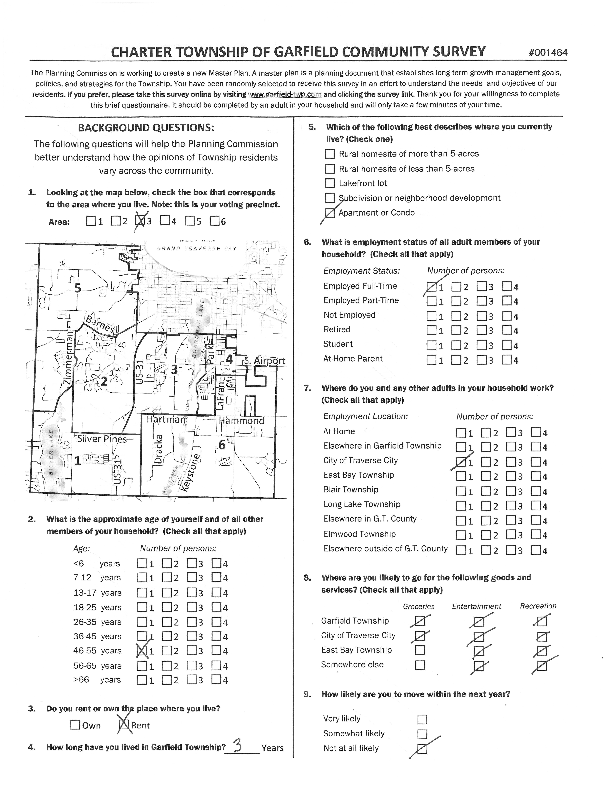

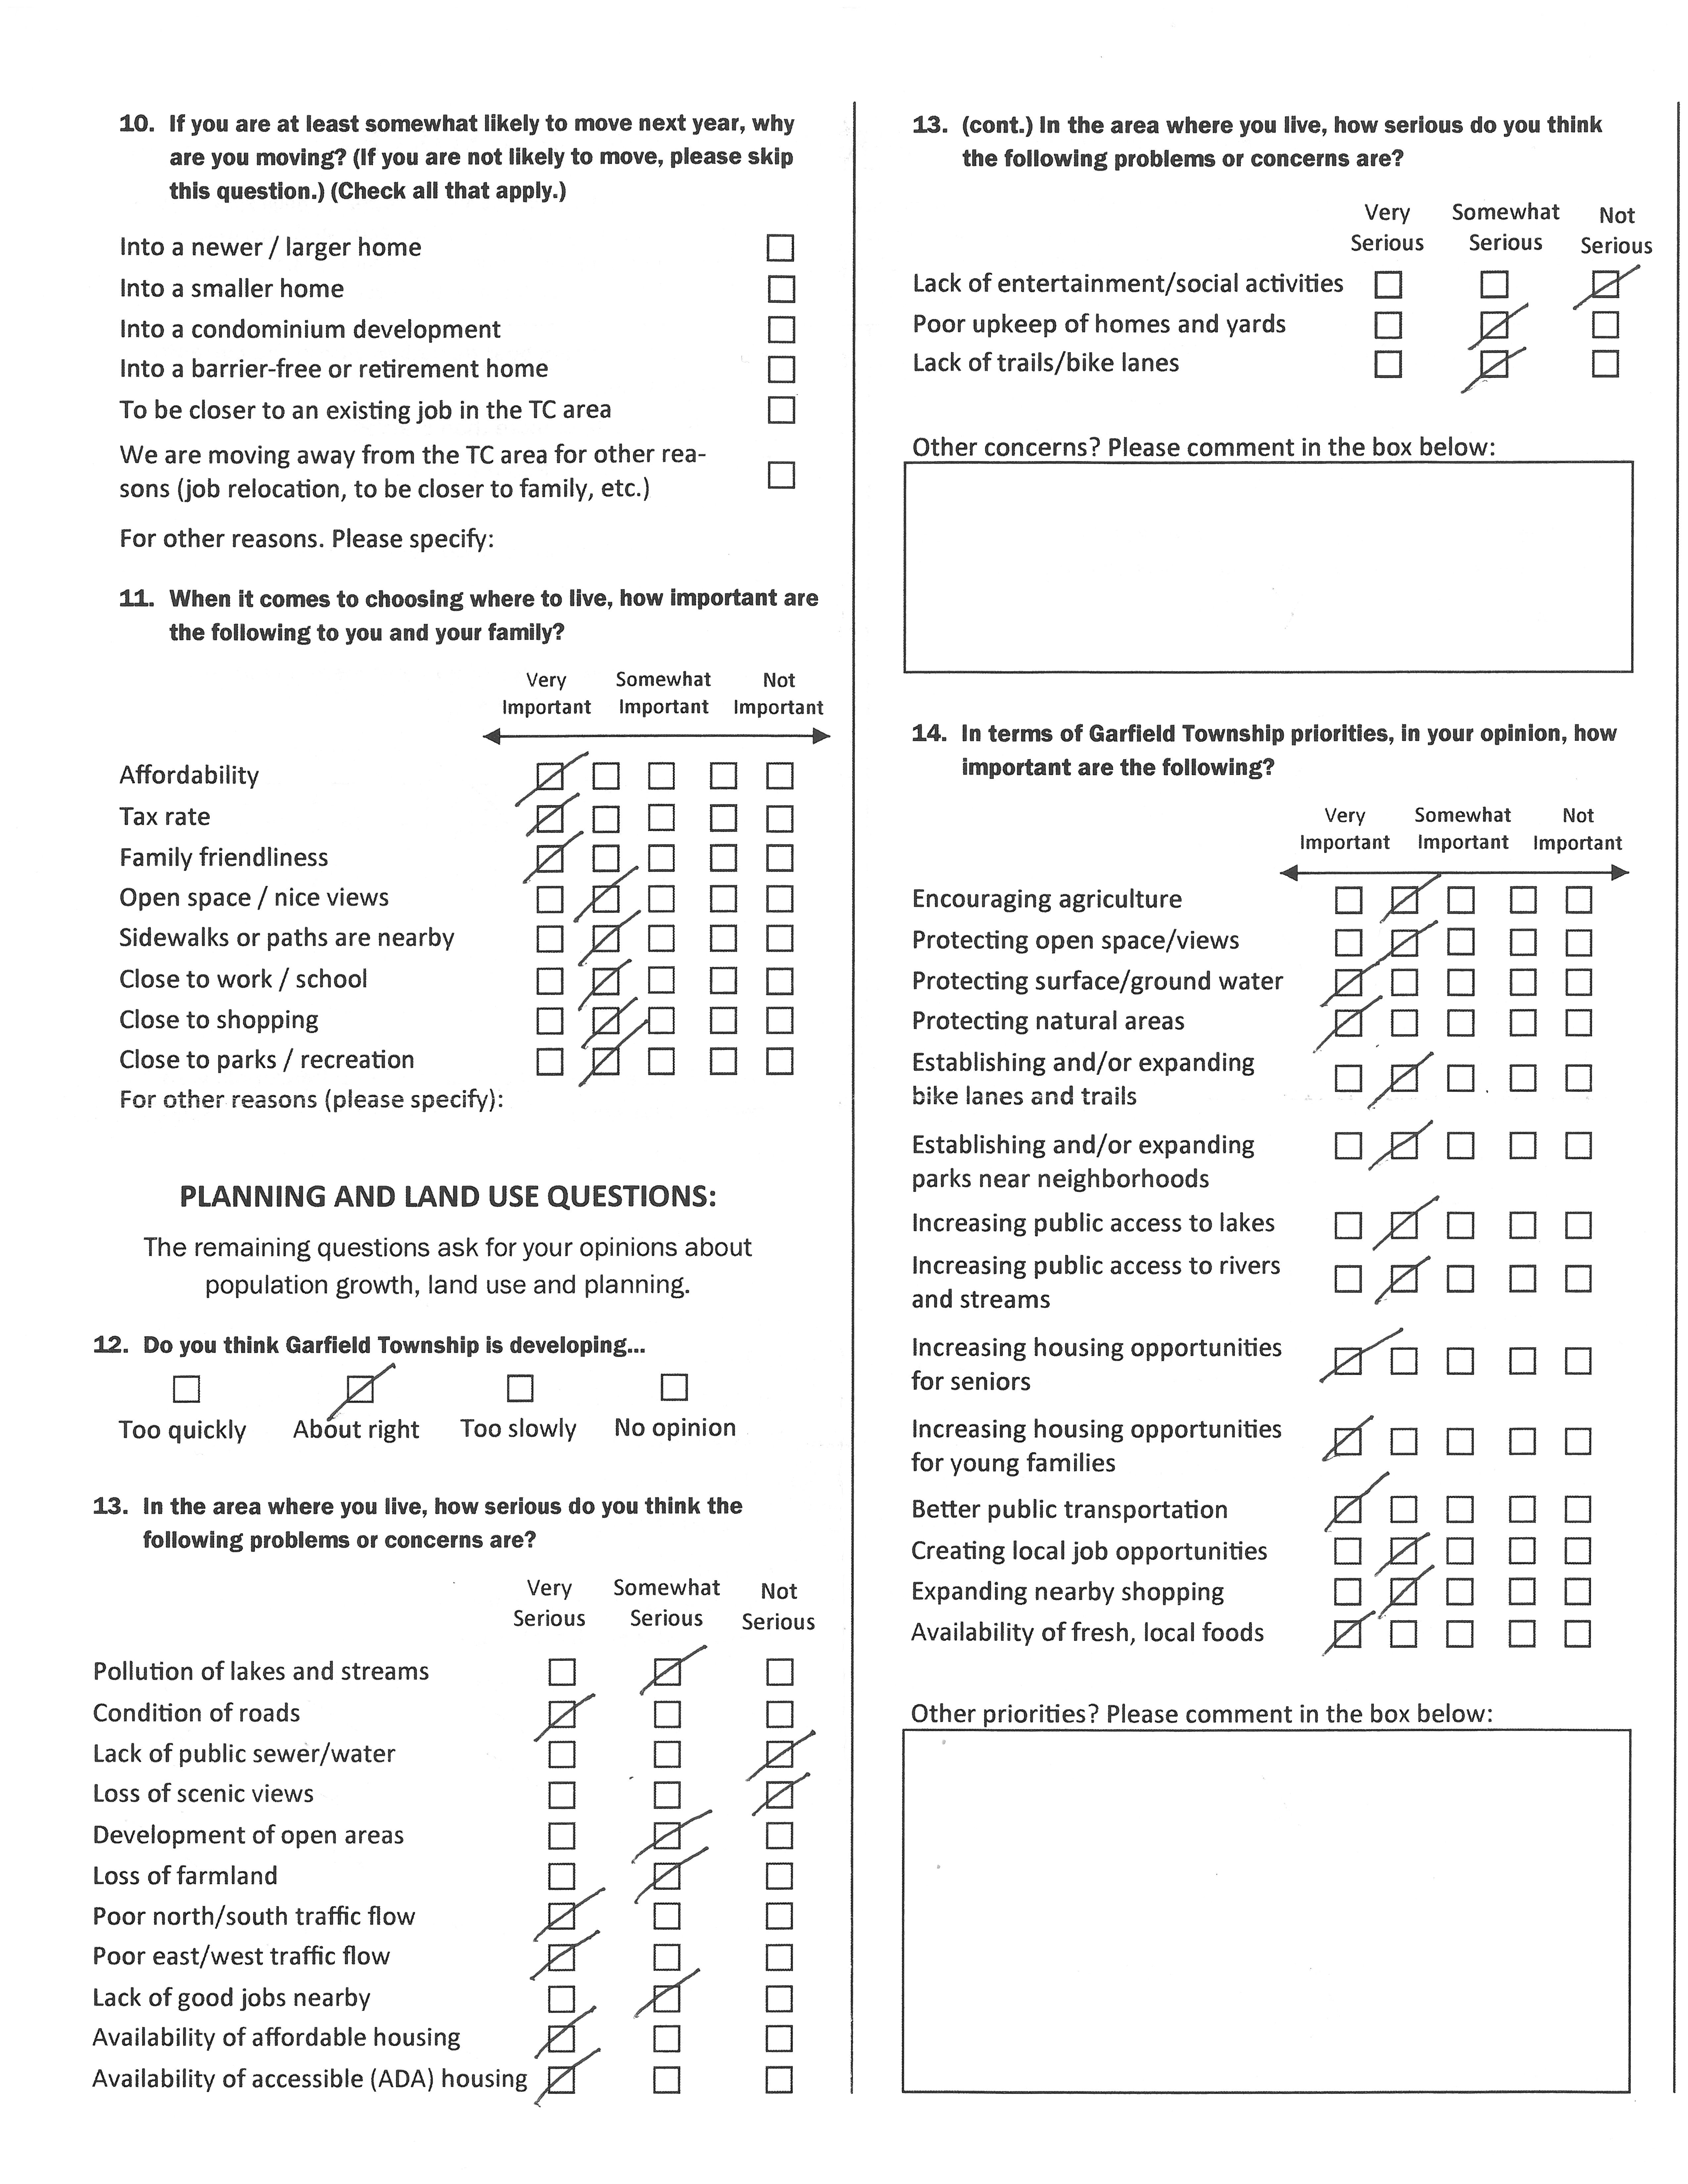

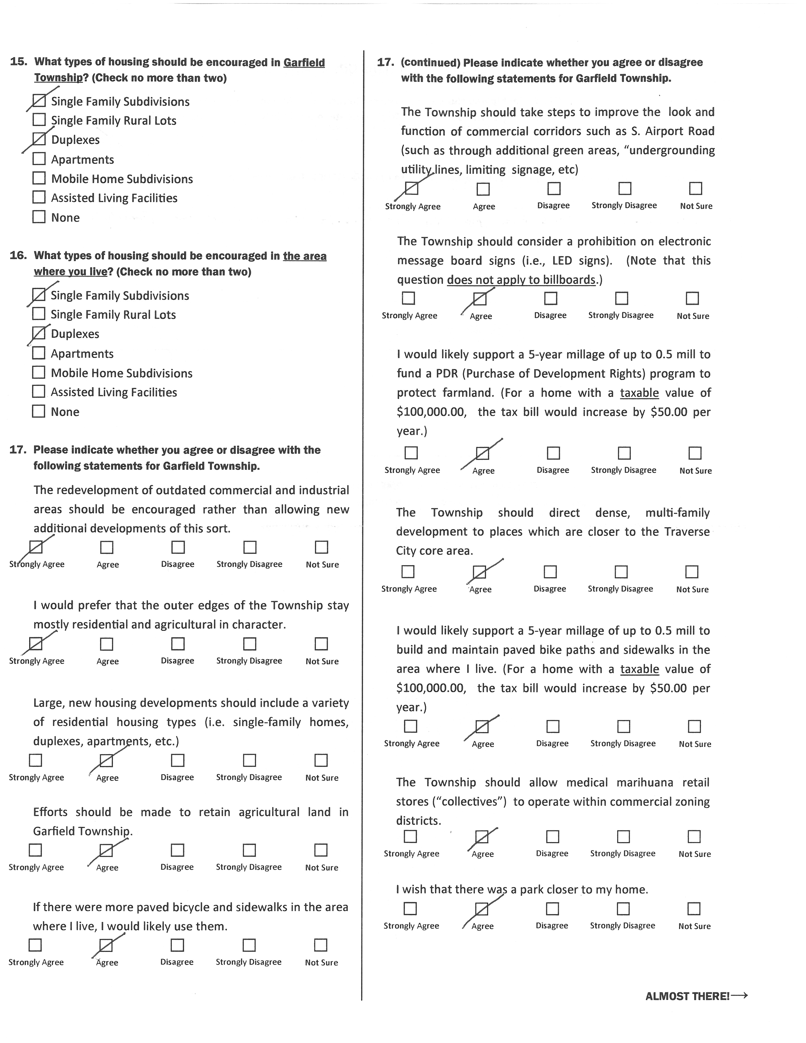

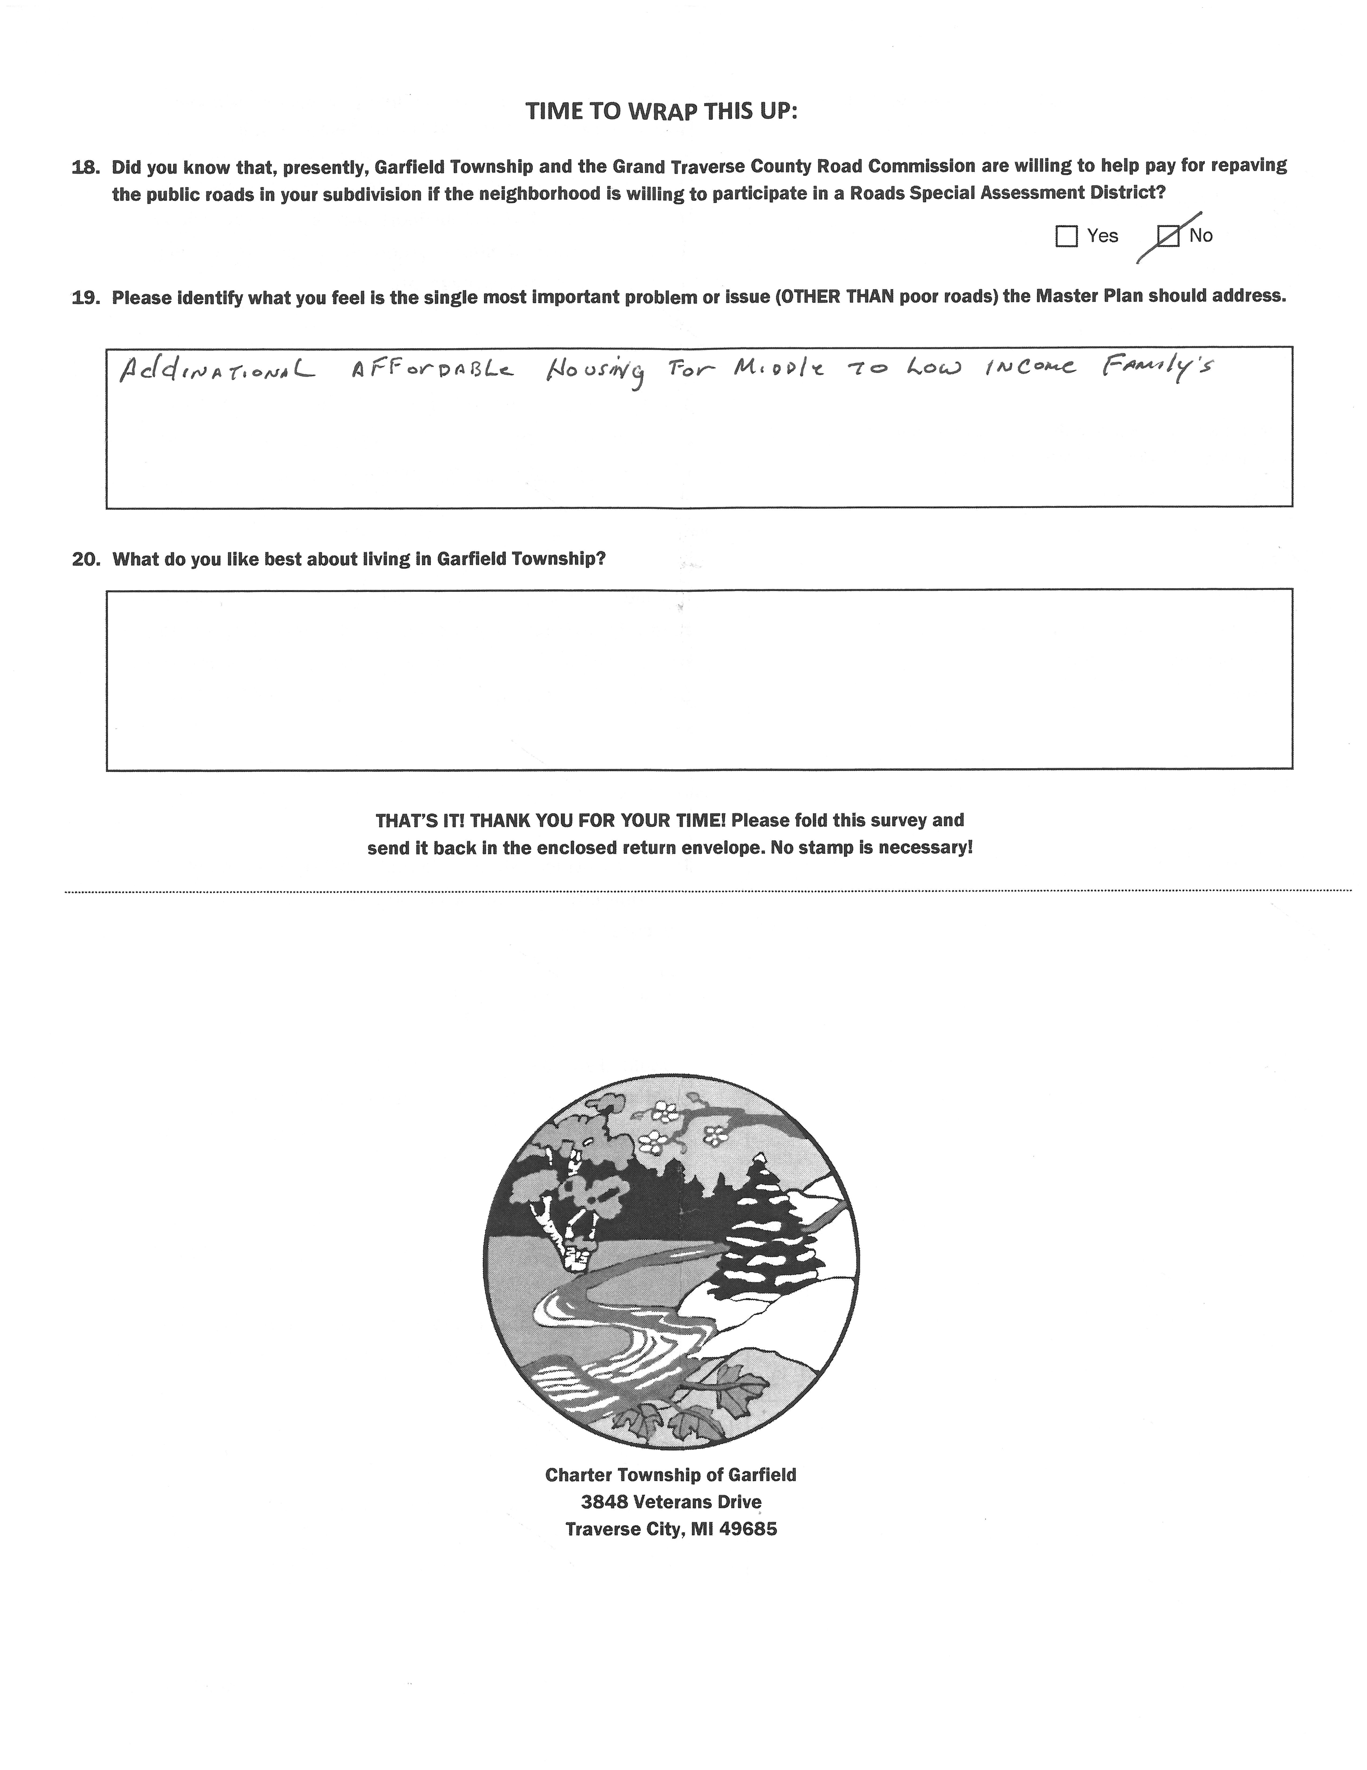

Chapter data sources: U.S. Census; 2013 Grand Traverse County Master Plan
2015 American Community Survey 5-Year Population Estimate
Source: Garfield Township Building Department January 2017. Please note that non-single family residential values are included in the Commercial Construction charts.
The data source for all housing element facts except as otherwise cited are the 2012 Grand Traverse County Housing Inventory and the 2013 Housing Strategy (DRAFT), as prepared by the Northwest Michigan Council Of Governments (NWMCOG)
Disability Network Northern Michigan
http://www.glcrailroad.com/passenger.php
https://www.tbaisd.k12.mi.us/about_us/about_tcaps.html
https://www.nmc.edu/about/index.html
The Boardman Lake Management Plan is available for review Watershed Center Grand Traverse Bay webpage, www.gtbay.org under “About Us” -> “Achievements.”

